**SECTION B ON SPSS**

**ANALYSING WITH STATISTICAL PACKAGE SOCIAL SCIENCES (SPSS)**

**PRACTICAL SEVEN: SPSS TUTORIAL.**

**INTRODUCTION TO THE INTERFACE OF THE SPSS**

After opening the SPSS application and it brings you to the SPSS interface. It now left for you to search on the menu bar and click on File and click on New to start a new project or better still you click on Open to a data as illustrated below:

* From the Menus choose:

File > Open > Data…..

Then a dialog box for opening files surfaces. Then you click on the file you saved earlier. Then the data file is displayed in the Data Editor.

**USING THE DATA EDITOR**

The Data Editor displays the contents of the active data file. The information in the Data Editor consists of Variables and Cases.

* In Data View, column represents variables and rows represent cases.
* In Variable View, each row is a variable and each column is an attribute that is associated with that variable.

Variables are used to represents different types of data that you have compiled. A common analogy is that of a survey. The response to each question on a survey is equivalent to a variable. Variables come in many different types including numbers, strings, currency and dates.

**ENTERING NUMERIC DATA**

Data can be entered into the Data Editor, which may be useful for small data files or for making minor edits to larger data files.

* Click the variable view tab at the bottom of the Data Editor window.

You need to define the variables that will be used. For example, in the case where only three variables are needed; age, marital status and income.

* In the first row of the first column, type age.
* In the second row, type marital.
* In the third row, type Income.

You observe that the names that you entered in variable view are now the headings for the first three column in Data View. Then begin entering in the first row, starting at the first column;

* Click the variable view tab at the bottom of the Data Editor window.
* In the Decimal column of the age row, type 0 to hide the decimal.
* In the Decimal column of the marital row, type 0 to hide the decimal.

**ENTERING STRING DATA**

Non-numeric data such as strings of text can also be entered into the Data Editor.

* Click the variable view tab at the bottom of the Data Editor window.
* In the first cell of the first empty row, type sex for variable name.
* Click the button on the right side of the type cell to open the variable type dialog box.
* Select String to specify the variable type.
* Click OK to save your selection and return to the Data Editor.

**READING DATA**

Data can be entered directly or it can be imported from a number of different sources. The process of reading data stored in IBM SPSS statistics data file; Spreadsheet applications such as Microsoft Excel or Data Base applications such as Microsoft Access and Text Files are all discussed in the chapter.

In this data file, case represents individual respondents to a survey and variables represent responses to each question asked in the survey.

Rather than typing all your data directly to data editor, you can read data from applications such as Microsoft Excel. You can also read column headings as variable names. To do this, you must follow the steps as shown below:

* From the menus choose

File > Open > Data……

* Then select Excel(*.xls) as the file type you want to view
* Then open demo.xls

The opening Excel data source dialog box is displayed, allowing you to specify whether variable names are to be included in the spreadsheet as well as the cells that you want to import

* Make sure that Read Variable names from the first row of data is selected. This option reads column headings as variable names

**NOTE:** If you want to import only a portion of the spreadsheet, specify the range of cells to be imported in the range text box

* Click OK to read the Excel File

Then the data now appear in the Data Editor, with the column headings used as variable names.

NOTE: Since variable names can’t contain spaces, the spaces from the original column headings have been removed. The original column heading is retained as a variable label.

**DEFINING DATA**

In addition to defining data types, you can also defines descriptive variable labels and value labels for variable names and data values. These descriptive labels are used in statistical reports and charts.

**ADDING VARIABLE LABELS**

Labels are meant to provide description of variables. These descriptions are often longer versions of variable names. Labels can be up to 255 bytes. These labels are used in your output to identify the different variables.

* Click variables view tab at the bottom of the Data Editor window.
* In the label column of the age row, type Respondent’s Age.
* In the label column of the marital row, type Marital Status.
* In the label column of the marital row, type Household Income.
* In the label column of the sex row, type Gender.

**CHANGING VARIABLE TYPE AND FORMAT**

The type column displays the current data type for each variable. The most common data types are numeric and string but many other formats are supported. In the current data file, the income variable is defined as a numeric type.

* Click the type cell for the income row and then click the button on the right side of the cell to open the variable type dialog box.
* Select Dollar.

The formatting options for the currently selected data type are displayed

* For the format of the currency in this example, select $###, ###, ###.
* Click OK to save your changes.

**ADDING VALUE LABELS FOR NUMERIC VARIABLES**

Value labels provide a method for mapping your variables values to a string label. In thus example, there are two acceptable values for the material variable. A value of 0 means that the subject is Single and a value of 1 means Married.

* Click the value cells for the marital row and then click the button on the right side of the cell to open the value labels dialog box.
* Type 0 in the value field.
* Type single in the label field
* Click Add to add this label to the list.
* Type 1 in the view and type Married in the label field.
* Click Add and then click OK to save your changes and return to the data editor.
* Click the data view tab at the bottom of the data editor window
* From the menus choose:

View > Value labels

Then the labels are displayed in a list whenever you enter value in the data editor which also help to provide a more descriptive answer.

**ADDING VALUE LABELS FOR STRING VARIABLES**

String variables may require value labels as well. For example your data may use single letter M or F to identify the sex of the object. Value label can be used to notify that M is for Male and F is Female.

* Click the variable view tab at the bottom of the data editor window.
* Click the values cell in the sex row and then click the button on the right side of the cell to open the value labels dialog box.
* Type F in the value field and then type Female in the label.
* Click Add to add this value to your data file.
* Type M in the value field and then type Male in the label.
* Click Add to add this value to your data file.
* Then click OK to save your change and return to the data editor.

NOTE: Because string values are case sensitive, you should be consistent. A lowercase m is not the same as the uppercase M.

**USING VALUE LABELS FOR DATA ENTRY**

You can use value labels for data entry.

* Click the data view tab at the bottom of the data editor window.
* In the first row, select the cell for sex.
* Click the button on the right side of the cell and then choose Male from the drop down list.
* In the second row, select the cell for the sex.
* Click the button on the right side of the cell and then choose Female from the drop down list.

**COPY AND PASTING VARIABLE ATTRIBUTES**

After defining variable attributes for variable, you can copy these attributes and apply them to other variables.

* In variable view, type agewed in the first cell of the first empty row
* In the label column, type Age married
* Click the values cell in the age row.
* From the menus choose:

Edit > Copy

* Click the values cell in agewed row
* From the menus choose

Edit > Paste

The defined values from the age variable are now applied to agewed variable. To apply the attribute to multiple variables, simply select multiple target cells.

* Click and drag down the column

When you paste the attribute, it is applied to all the selected cells and new variables are automatically created if you paste the values into empty rows. To copy all the attributes from one variable to another variable.

* Click the row numbers in the marital row
* From the menus choose:

Edit > Copy

* Click the row number of the first empty row
* From the menus choose:

Edit > Paste

All attributes of the marital variable are applied to the new variable.

**EXAMINING SUMMARY STATISTICS FOR INDIVIDUAL VARIABLES**

**SUMMARY MEASURES FOR CATEGORIAL DATA**

After inputting and doing other necessary things in the data file displayed then you move to doing the analysis of the data.

Firstly, You start by creating a simple frequency table (i.e. Table of counts) and this requires the statistical base options. To get the simple frequency table, we follow the steps as shown below;

* From the menus choose:

Analyze > Descriptive statistics > Frequencies

* Then the frequency dialog box is displayed, where you click the first variable you want to work with. If after clicking the variable in question appears has being noted, you then drag and drop it to the variable(s) list on the right. Then you click on the other variable you want to work with. Then you drag and drop it to the variable(s) list on the right
* Click OK to run the procedure

Then the result is displayed in the viewer window, where we have the frequency tables for the categories in question.

Secondly, You move to creation of charts. For example we can create a chart to show the relationship between two or more data as stated in the question. To do this, you follow the steps as stated below:

* From the menus choose:

Graphs > Chart Builder

* Click the Gallery tab
* Click the Graph you want to work with i.e. either Bar, Histogram, Pie or any other type of graph

For example let’s say I click on Bar. I then drag the clustered Bar icon onto the canvas, which is the large area above the Gallery.

* Then scroll down the variable list, click the variable in question and then choose Nominal as it measurement level.
* Then click and drag the variable in question to the X-axis
* Then scroll down the variable list, click the second variable in question and then choose Nominal as it measurement level.
* Then click and drag the variable in question to the Cluster drop zone in the upper right corner of the canvas.
* Click OK to create the chart.

Then the bar chart is then displayed in the viewer window.

**SUMMARY MEASURES FOR SCALE VARIABLES**

There are many summary measures available for scale variables including:

**MEASURES OF CENTRAL TENDENCY**

The most common measures if central tendency are the mean (arithmetic mean) and median (value at which half the cases fall above and below).

**MEASURES OF DISPERSION**

Statistics measures the amount of variation or spend in the data which include the standard deviation, minimum and maximum.

* Open the frequencies dialog box again
* Click reset to clear any previous settings
* Select the specific data in question and move it into the variable(s) list
* Click statistics
* Select Mean, Median, Std. deviation, Minimum and Maximum
* Click continue
* Deselect display frequency
* Click OK to run the procedure

Then the frequency statistics table is displayed in the viewer window

* Open the frequency dialog box again
* Click charts
* Select Histogram and with normal curve
* Click continue and then click OK in the main dialog box to run the procedure.

Then you have the chart showing the characteristics of the data in question.

**CROSSTABULATION TABLES**

Cross tabulation tables (contingency table) display the relationship between two or more categories (nominal or ordinal) variables.

**A SIMPLE CROSSTABULTION**

To get a simple cross tabulation, we follow the steps below:

* From menus choose:

Analyze > Descriptive statistics > Crosstabs

* Select the variable in question as the row variable
* Select other variable in question as the column variable
* Click OK to run the procedure.

Then it displays the simple cross tabulation of the two variables which shows the relationship between them.

**COUNTS VS. PERCENTAGE**

It is often difficult to analyze a cross tabulation simply by looking at the simple counts in each cell. To get the counts vs. percentage the two variables, we follow the steps below:

* Open the crosstabs dialog box again and the two variables should still be selected
* You can use the dialog box recall button on the toolbar to quickly return to recently used procedures.
* Click cells
* Click row in the percentage group
* Click continue and then click OK in the main dialog box to return the procedure.

A clearer picture now start to emerge which shows the counts vs. percentage between the two variables in question.

**SIGNIFICANCE TESTING FOR CROSSTABULATION**

A number of tests are available to determine if the relationship between two cross tabulated variables is significant. One of the more common tests is chi-square. To get the significance testing for cross tabulation, we follow the steps below:

* Open the crosstab dialog box again
* Click statistics
* Click chi-square
* Click continue and then click OK in the main dialog box to run the procedure.

Then Pearson’s chi-square tests the hypothesis that the row and column variables are independent. Then the significance value displays to the users windows.

**CREATING AND EDITING CHARTS**

**CHART CREATION**

You can create and edit a wide variety of chart types. In these examples, we will create and edit three commonly used types of charts:

• Simple bar chart

• Pie chart

• Scatterplot with groups

To demonstrate the basics of chart creation, we will create a bar chart of mean income for different levels of job satisfaction. This example uses the data file *demo.sav*.

► From the menus choose:

Graphs > Chart Builder...

The Chart Builder dialog box is an interactive window that allows you to preview how a chart will look while you build it. The Gallery includes many different predefined charts,

which are organized by chart type. The Basic Elements tab also provides basic elements (such as axes and graphic elements) for creating charts from scratch, but it's easier to use the Gallery.

► Click **Bar** if it is not selected.

Icons representing the available bar charts in the Gallery appear in the dialog box. The pictures should provide enough information to identify the specific chart type. If you need more information, you can also display a ToolTip description of the chart by pausing your cursor over an icon.

► Drag the icon for the simple bar chart onto the "canvas," which is the large area above the Gallery. The Chart Builder displays a preview of the chart on the canvas. Note that the data used to draw the chart are not your actual data. They are example data.

Although there is a chart on the canvas, it is not complete because there are no variables or statistics to control how tall the bars are and to specify which variable category corresponds to each bar. You can't have a chart without variables and statistics. You add variables by dragging them from the Variables list, which is located to the left of the canvas. When you drag the variables, the targets are "drop zones" on the canvas. Some drop zones require a variable while others do not. The drop zone for the *x* axis is required. The variable in this drop zone controls where the bars appear on the *x* axis. Depending on the type of chart you are creating, you may also need a variable in the *y* axis drop zone. For example, when you want to display a summary statistic of another variable (such as mean of salary), you need a variable in the *y* axis drop zone. Scatterplots also require a variable in the *y* axis. In that case, the drop zone identifies the dependent variable. A variable's measurement level is important in the Chart Builder. You are going to use the *Job satisfaction* variable on the *x* axis. However, the icon (which looks like a ruler) next to the variable indicates that its measurement level is defined as scale. To create the correct chart, you must use a categorical measurement level. Instead of going back and changing the measurement level in the Variable View, you can change the measurement level temporarily in the Chart Builder.

► Right-click *Job satisfaction* in the Variables list and choose **Ordinal**. Ordinal is an appropriate measurement level because the categories in*Job satisfaction* can be ranked

by level of satisfaction. Note that the icon changes after you change the measurement level.

► Now drag *Job satisfaction* from the Variables list to the *x* axis drop zone.

The *y* axis drop zone defaults to the *Count* statistic. If you want to use another statistic (such as percentage or mean), you can easily change it. You will not use either of these statistics in this example, but we will review the process in case you need to change this statistic at another time.

► Click **Element Properties** to display the Element Properties window.

The Element Properties window allows you to change the properties of the various chart elements. These elements include the graphic elements (such as the bars in the bar chart) and the axes on the chart. Select one of the elements in the Edit Properties of list to change the properties associated with that element. Also note the red *X* located to the right of the list. This button deletes a graphic element from the canvas. Because **Bar1** is selected, the properties shown apply to graphic elements, specifically the bar graphic element. The Statistic drop-down list shows the specific statistics that are available. The same statistics are usually available for every chart type. Be aware that some statistics require that the *y* axis drop zone co

► Double-click the Warnings icon to hide warning messages in the output.

► Click OK to save your changes and close the dialog box. Contains a variable. Return to the Chart Builder dialog box and drag *Household income in thousands* from the Variables list to the *y* axis drop zone. Return to the Chart Builder dialog box and drag *Household income in thousands* from the Variables list to the *y* axis drop zone. You can also add titles and footnotes to the chart.

► Click the **Titles/Footnotes** tab.

► Select **Title 1**.

The title appears on the canvas with the label **T1**.

► In the Element Properties window, select **Title 1** in the Edit Properties of list.

► In the Content text box, type **Income by Job Satisfaction**. This is the text that the title will display.

► Click **Apply** to save the text. Although the text is not displayed in the Chart Builder, it will appear when you generate the chart.

► Click **OK** to create the bar chart.

The bar chart reveals that respondents who are more satisfied with their jobs tend to have higher household incomes.

**CHART EDITING**

You can edit charts in a variety of ways. For the sample bar chart that you created, you will:

• Change colors.

• Format numbers in tick labels.

• Edit text.

• Display data value labels.

• Use chart templates.

To edit the chart, open it in the Chart Editor.

► Double-click the bar chart to open it in the Chart Editor.

**USING THE PROERPTIES WINDOW**

► From the Chart Editor menus choose:

Edit > Properties

This opens the Properties window, showing the tabs that apply to the bars you selected. These tabs change depending on what chart element you select in the Chart Editor. For example, if you had selected a text frame instead of bars, different tabs would appear in the Properties window. You will use these tabs to do most chart editing.

First, you will change the color of the bars. You specify color attributes of graphic elements (excluding lines and markers) on the Fill & Border tab.

► Click the **Fill & Border** tab.

► Click the swatch next to Fill to indicate that you want to change the fill color of the bars. The numbers below the swatch specify the red, green, and blue settings for the current color.

► Click the light blue color, which is second from the left in the second row from the bottom.

► Click **Apply**.

**FORMATTING NUMBERS IN TICK LABELS**

► Double-click the **Warnings**icon to hide warning messages in the output.

► Click **OK** to save your changes and close the dialog box.

Notice that the numbers on the *y* axis are scaled in thousands. To make the chart more attractive and easier to interpret, we will change the number format in the tick labels and then edit the axis title appropriately.

► Select the *y* axis tick labels by clicking any one of them.

► To reopen the Properties window (if you closed it previously), from the menus choose:

Edit > Properties

***Note*:** From here on, we assume that the Properties window is open. If you have closed the Properties window, follow the previous step to reopen it. You can also use the keyboard shortcut Ctrl+T to reopen the window.

Different tabs are available now that the tick labels are selected instead of the bars.

► Click the **Number Format** tab.

► You do not want the tick labels to display decimal places, so type **0** in the Decimal Places text box.

► Type **0.001** in the Scaling Factor text box. The scaling factor is the number by which the Chart Editor divides the displayed number. Because **0.001** is a fraction, dividing by it will *increase* the numbers in the tick labels by 1,000. Thus, the numbers will no longer be in thousands; they will be unscaled.

► Select **Display Digit Grouping**. Digit grouping uses a character (specified by your computer's locale) to mark each thousandth place in the number.

► Click **Apply**.

The tick labels reflect the new number formatting: There are no decimal places, the numbers are no longer scaled, and each thousandth place is specified with a character.

**DISPLAYING DATA VALUE LABELS**

Another common task is to show the exact values associated with the graphic elements (which are bars in this example). These values are displayed in data labels.

► From the Chart Editor menus choose:

Elements > Show Data Labels

Each bar in the chart now displays the exact mean household income. Notice that the units are in thousands, so you could use the Number Format tab again to change the scaling factor.

**USING TEMPLATES**

If you make a number of routine changes to your charts, you can use a chart template to reduce the time needed to create and edit charts. A chart template saves the attributes of a specific chart. You can then apply the template when creating or editing a chart.

We will save the current chart as a template and then apply that template while creating a new chart.

► From the menus choose:

File > Save Chart Template...

The Save Chart Template dialog box allows you to specify which chart attributes you want to include in the template. If you expand any of the items in the tree view, you can see which specific attributes can be saved with the chart. For example, if you expand the **Scale axes** portion of the tree, you can see all of the attributes of data value labels that the template will include. You can select any attribute to include it in the template.

► Select **All settings** to include all of the available chart attributes in the template.

You can also enter a description of the template. This description will be visible when you apply the template.

► Click **Continue**.

► In the Save Template dialog box, specify a location and filename for the template.

► When you are finished, click **Save**.

You can apply the template when you create a chart or in the Chart Editor. In the following example, we will apply it while creating a chart.

► Close the Chart Editor. The updated bar chart is shown in the Viewer.

► From the Viewer menus choose:

Graphs > Chart Builder...

The Chart Builder dialog box "remembers" the variables that you entered when you created the original chart. However, here you will create a slightly different chart to see how applying a template formats a chart.

► Remove *Job satisfaction* from the *x* axis by dragging it from the drop zone back to the Variables list. You can also click the drop zone and press Delete.

► Right-click *Level of education* in the Variables list and choose **Ordinal**.

► Drag *Level of education* from the Variables list to the *x* axis drop zone.

► On the Titles/Footnotes tab, deselect **Title 1**.

Now we are going to specify the template to apply to the new chart.

► Click **Options**.

► In the Templates group in the Options dialog box, click **Add**.

► In the Find Template Files dialog box, locate the template file that you previously saved using the Save Chart Template dialog box.

► Select that file and click **Open**.

The Options dialog box displays the file path of the template you selected.

► Click **OK** to close the Options dialog box.

► Click **OK** on the Chart Builder dialog box to create the chart and apply the template.

The formatting in the new chart matches the formatting in the chart that you previously created and edited. Although the variables on the *x* axis are different, the charts otherwise resemble each other. Notice that the title from the previous chart was preserved in the template, even though you deleted the title in the Chart Builder.

If you want to apply templates after you've created a chart, you can do it in the Chart Editor (from the File menu, choose **Apply Chart Template**).

**DEFINING CHART OPTIONS**

In addition to using templates to format charts, you can use the Options to control various aspects of how charts are created.

► From the Data Editor or Viewer menus choose:

Edit > Options...

The Options dialog box contains many configuration settings. Click the **Charts** tab to see the available options. The options control how a chart is created. For each new chart, you can specify:

• Whether to use the current settings or a template.

• The width-to-height ratio (aspect ratio).

• If you're not using a template, the settings to use for formatting.

• The style cycles for graphic elements.

Style cycles allow you to specify the style of graphic elements in new charts. In this example, we'll look at the details for the color style cycle.

► Click **Colors** to open the Data Element Colors dialog box.

For a simple chart, the Chart Editor uses one style that you specify. For grouped charts, the Chart Editor uses a set of styles that it cycles through for each group (category) in the chart.

► Select **Simple Charts**.

► Select the light green color, which is third from the right in the second row from the bottom.

► Click **Continue**.

► In the Options dialog box, click **OK** to save the color style cycle changes.

The graphic elements in any new simple charts will now be light green.

► From the Data Editor or Viewer menus choose:

Graphs > Chart Builder...

The Chart Builder displays the last chart you created. Remember that this chart had a template associated with it. We no longer want to use that template.

► Click **Options**.

► Deselect (uncheck) the template that you added previously. Note that you could also click the red *X* to delete the template. By deselecting rather than deleting, you keep the template available to use at another time.

► Click **OK** to create the chart.

The bars in the new chart are light green. This chart also differs from the last one in other ways. There is no title; the axis labels are in thousands; and there are no data labels. The differences occurred because the template wasn't applied to this chart.

**WORKING WITH OUTPUT**

The results from running a statistical procedure are displayed in the Viewer. The output produced can be statistical tables, charts, graphs, or text, depending on the choices you make when you run the procedure. This section uses the files *viewertut.spv* and *demo.sav*. See the topic [Sample Files](http://desktop-voceprg:51518/help/topic/com.ibm.spss.statistics.help/data_files.htm) for more information.

**USING THE VIEWER**

The Viewer window is divided into two panes. The **outline pane** contains an outline of all of the information stored in the Viewer. The **contents pane** contains statistical tables, charts, and text output. Use the scroll bars to navigate through the window's contents, both vertically and horizontally. For easier navigation, click an item in the outline pane to display it in the contents pane.

► Click and drag the right border of the outline pane to change its width.

An open book icon in the outline pane indicates that it is currently visible in the Viewer, although it may not currently be in the visible portion of the contents pane.

► To hide a table or chart, double-click its book icon in the outline pane.

The open book icon changes to a closed book icon, signifying that the information associated with it is now hidden.

► To redisplay the hidden output, double-click the closed book icon.

You can also hide all of the output from a particular statistical procedure or all of the output in the Viewer.

► Click the box with the minus sign (−) to the left of the procedure whose results you want to hide, or click the box next to the topmost item in the outline pane to hide all of the output.

The outline collapses, visually indicating that these results are hidden. You can also change the order in which the output is displayed.

► In the outline pane, click on the items that you want to move.

► Drag the selected items to a new location in the outline and release the mouse button.

You can also move output items by clicking and dragging them in the contents pane.

**USING THE PIVOT TABLE EDITOR**

The results from most statistical procedures are displayed in **pivot tables**.

Many statistical terms are displayed in the output. Definitions of these terms can be accessed directly in the Viewer.

► Double-click the *Owns PDA * Gender * Internet Crosstabulation* table.

► Right-click *Expected Count* and choose **What's This?** From the pop-up context menu.

The definition is displayed in a pop-up window. The default tables produced may not display information as neatly or as clearly as you would like. With pivot tables, you can transpose rows and columns ("flip" the table), adjust the order of data in a table, and modify the table in many other ways. For example, you can change a short, wide table into a long, thin one by transposing rows and columns. Changing the layout of the table does not affect the results. Instead, it's a way to display your information in a different or more desirable manner.

► If it's not already activated, double-click the *Owns PDA * Gender * Internet Crosstabulation* table to activate it.

► If the Pivoting Trays window is not visible, from the menus choose:

Pivot > Pivoting Trays

Pivoting trays provide a way to move data between columns, rows, and layers.

► Drag the *Statistics* element from the Row dimension to the Column dimension, below *Gender*. The table is immediately reconfigured to reflect your changes.

The order of the elements in the pivoting tray reflects the order of the elements in the table.

► Drag and drop the *Owns PDA* element before the *Internet* element in the row dimension to reverse the order of these two rows.

**CREATING AND DISPLAYING LAYERS**

Layers can be useful for large tables with nested categories of information. By creating layers, you simplify the look of the table, making it easier to read.

► If the *Owns PDA * Gender * Internet Crosstabulation* table is not already activated, double-click the table to activate it.

► If the Pivoting Trays window is not visible, from the menus choose:

Pivot > Pivoting Trays

► Drag the *Gender* element from the Column dimension to the Layer dimension.

To display a different layer, select a category from the drop-down list in the table.

**EDITING TABLES**

Unless you've taken the time to create a custom Table Look, pivot tables are created with standard formatting. You can change the formatting of any text within a table. Formats that you can change include font name, font size, font style (bold or italic), and color.

► Double-click the *Level of education* table.

► If the Formatting toolbar is not visible, from the menus choose:

View > Toolbar

► Click the title text, *Level of education*.

► From the drop-down list of font sizes on the toolbar, choose **12**.

► To change the color of the title text, click the text color tool and choose a new color.

You can also edit the contents of tables and labels. For example, you can change the title of this table.

► Double-click the title.

► Type **Education Level** for the new label.

*Note*: If you change the values in a table, totals and other statistics are not recalculated.

**HIDING ROWS AND COLUMNS**

Some of the data displayed in a table may not be useful or it may unnecessarily complicate the table. Fortunately, you can hide entire rows and columns without losing any data.

► If it's not already activated, double-click the *Education Level* table to activate it.

► Click *Valid Percent* column label to select it.

► From the Edit menu or the right-click context menu choose:

Select > Data and Label Cells

► From the View menu choose **Hide** or from the right-click context menu choose **Hide Category**.

The column is now hidden but not deleted.

To redisplay the column:

► From the menus choose:

View > Show All

Rows can be hidden and displayed in the same way as columns.

**CHANGING DATA DISPLAY FORMAT**

You can easily change the display format of data in pivot tables.

► If it's not already activated, double-click the *Education Level* table to activate it.

► Click on the *Percent* column label to select it.

► From the Edit menu or the right-click context menu choose:

Select > Data Cells

► From the Format menu or the right-click context menu choose **Cell Properties**.

► Click the **Format Value** tab.

► Type **0** in the Decimals field to hide all decimal points in this column.

You can also change the data type and format in this dialog box.

► Select the type that you want from the Category list, and then select the format for that type in the Format list.

► Click **OK** or **Apply** to apply your changes.

The decimals are now hidden in the *Percent* column.

**TABLE LOOKS**

The format of your tables is a critical part of providing clear, concise, and meaningful results. If your table is difficult to read, the information contained within that table may not be easily understood.

► Double-click the *Marital status* table.

► From the menus choose:

Format > TableLooks..

The TableLooks dialog box lists a variety of predefined styles. Select a style from the list to preview it in the Sample window on the right. You can use a style as is, or you can edit an existing style to better suit your needs.

► To use an existing style, select one and click **OK**.

You can customize a format to fit your specific needs. Almost all aspects of a table can be customized, from the background color to the border styles.

► Double-click the *Marital status* table.

► From the menus choose:

Format > TableLooks...

► Select the style that is closest to your desired format and click **Edit Look**.

► Click the **Cell Formats** tab to view the formatting options.

The formatting options include font name, font size, style, and color. Additional options include alignment, text and background colors, and margin sizes. The Sample window on the right provides a preview of how the formatting changes affect your table. Each area of the table can have different formatting styles. For example, you probably wouldn't want the title to have the same style as the data. To select a table area to edit, you can either choose the area by name in the Area drop-down list, or you can click the area that you want to change in the Sample window.

► Select **Data** from the Area drop-d **PRACTICAL SEVEN: FORM A COMPREHENSIVE NOTE FROM THE TUTORIAL OF SPSS**

**INTRODUCTION TO THE INTERFACE OF THE SPSS**

After opening the SPSS application and it brings you to the SPSS interface. It now left for you to search on the menu bar and click on File and click on New to start a new project or better still you click on Open to a data as illustrated below:

* From the Menus choose:

File > Open > Data…..

Then a dialog box for opening files surfaces. Then you click on the file you saved earlier. Then the data file is displayed in the Data Editor.

**USING THE DATA EDITOR**

The Data Editor displays the contents of the active data file. The information in the Data Editor consists of Variables and Cases.

* In Data View, column represents variables and rows represent cases.
* In Variable View, each row is a variable and each column is an attribute that is associated with that variable.

Variables are used to represents different types of data that you have compiled. A common analogy is that of a survey. The response to each question on a survey is equivalent to a variable. Variables come in many different types including numbers, strings, currency and dates.

**ENTERING NUMERIC DATA**

Data can be entered into the Data Editor, which may be useful for small data files or for making minor edits to larger data files.

* Click the variable view tab at the bottom of the Data Editor window.

You need to define the variables that will be used. For example, in the case where only three variables are needed; age, marital status and income.

* In the first row of the first column, type age.
* In the second row, type marital.
* In the third row, type Income.

You observe that the names that you entered in variable view are now the headings for the first three column in Data View. Then begin entering in the first row, starting at the first column;

* Click the variable view tab at the bottom of the Data Editor window.
* In the Decimal column of the age row, type 0 to hide the decimal.
* In the Decimal column of the marital row, type 0 to hide the decimal.

**ENTERING STRING DATA**

Non-numeric data such as strings of text can also be entered into the Data Editor.

* Click the variable view tab at the bottom of the Data Editor window.
* In the first cell of the first empty row, type sex for variable name.
* Click the button on the right side of the type cell to open the variable type dialog box.
* Select String to specify the variable type.
* Click OK to save your selection and return to the Data Editor.

**READING DATA**

Data can be entered directly or it can be imported from a number of different sources. The process of reading data stored in IBM SPSS statistics data file; Spreadsheet applications such as Microsoft Excel or Data Base applications such as Microsoft Access and Text Files are all discussed in the chapter.

In this data file, case represents individual respondents to a survey and variables represent responses to each question asked in the survey.

Rather than typing all your data directly to data editor, you can read data from applications such as Microsoft Excel. You can also read column headings as variable names. To do this, you must follow the steps as shown below:

* From the menus choose

File > Open > Data……

* Then select Excel(*.xls) as the file type you want to view
* Then open demo.xls

The opening Excel data source dialog box is displayed, allowing you to specify whether variable names are to be included in the spreadsheet as well as the cells that you want to import

* Make sure that Read Variable names from the first row of data is selected. This option reads column headings as variable names

**NOTE:** If you want to import only a portion of the spreadsheet, specify the range of cells to be imported in the range text box

* Click OK to read the Excel File

Then the data now appear in the Data Editor, with the column headings used as variable names.

NOTE: Since variable names can’t contain spaces, the spaces from the original column headings have been removed. The original column heading is retained as a variable label.

**DEFINING DATA**

In addition to defining data types, you can also defines descriptive variable labels and value labels for variable names and data values. These descriptive labels are used in statistical reports and charts.

**ADDING VARIABLE LABELS**

Labels are meant to provide description of variables. These descriptions are often longer versions of variable names. Labels can be up to 255 bytes. These labels are used in your output to identify the different variables.

* Click variables view tab at the bottom of the Data Editor window.
* In the label column of the age row, type Respondent’s Age.
* In the label column of the marital row, type Marital Status.
* In the label column of the marital row, type Household Income.
* In the label column of the sex row, type Gender.

**CHANGING VARIABLE TYPE AND FORMAT**

The type column displays the current data type for each variable. The most common data types are numeric and string but many other formats are supported. In the current data file, the income variable is defined as a numeric type.

* Click the type cell for the income row and then click the button on the right side of the cell to open the variable type dialog box.
* Select Dollar.

The formatting options for the currently selected data type are displayed

* For the format of the currency in this example, select $###, ###, ###.
* Click OK to save your changes.

**ADDING VALUE LABELS FOR NUMERIC VARIABLES**

Value labels provide a method for mapping your variables values to a string label. In thus example, there are two acceptable values for the material variable. A value of 0 means that the subject is Single and a value of 1 means Married.

* Click the value cells for the marital row and then click the button on the right side of the cell to open the value labels dialog box.
* Type 0 in the value field.
* Type single in the label field
* Click Add to add this label to the list.
* Type 1 in the view and type Married in the label field.
* Click Add and then click OK to save your changes and return to the data editor.
* Click the data view tab at the bottom of the data editor window
* From the menus choose:

View > Value labels

Then the labels are displayed in a list whenever you enter value in the data editor which also help to provide a more descriptive answer.

**ADDING VALUE LABELS FOR STRING VARIABLES**

String variables may require value labels as well. For example your data may use single letter M or F to identify the sex of the object. Value label can be used to notify that M is for Male and F is Female.

* Click the variable view tab at the bottom of the data editor window.
* Click the values cell in the sex row and then click the button on the right side of the cell to open the value labels dialog box.
* Type F in the value field and then type Female in the label.
* Click Add to add this value to your data file.
* Type M in the value field and then type Male in the label.
* Click Add to add this value to your data file.
* Then click OK to save your change and return to the data editor.

**NOTE:** Because string values are case sensitive, you should be consistent. A lowercase m is not the same as the uppercase M.

**USING VALUE LABELS FOR DATA ENTRY**

You can use value labels for data entry.

* Click the data view tab at the bottom of the data editor window.
* In the first row, select the cell for sex.
* Click the button on the right side of the cell and then choose Male from the drop down list.
* In the second row, select the cell for the sex.
* Click the button on the right side of the cell and then choose Female from the drop down list.

**COPY AND PASTING VARIABLE ATTRIBUTES**

After defining variable attributes for variable, you can copy these attributes and apply them to other variables.

In variable view, type agewed in the first cell

USING TEMPLATES

If you make a number of routine changes to your charts, you can use a chart template to reduce the time needed to create and edit charts. A chart template saves the attributes of a specific chart. You can then apply the template when creating or editing a chart.

We will save the current chart as a template and then apply that template while creating a new chart.

► From the menus choose:

File > Save Chart Template...

The Save Chart Template dialog box allows you to specify which chart attributes you want to include in the template. If you expand any of the items in the tree view, you can see which specific attributes can be saved with the chart. For example, if you expand the **Scale axes** portion of the tree, you can see all of the attributes of data value labels that the template will include. You can select any attribute to include it in the template.

► Select **All settings** to include all of the available chart attributes in the template.

You can also enter a description of the template. This description will be visible when you apply the template.

► Click **Continue**.

► In the Save Template dialog box, specify a location and filename for the template.

► When you are finished, click **Save**.

You can apply the template when you create a chart or in the Chart Editor. In the following example, we will apply it while creating a chart.

► Close the Chart Editor. The updated bar chart is shown in the Viewer.

► From the Viewer menus choose:

Graphs > Chart Builder...

The Chart Builder dialog box "remembers" the variables that you entered when you created the original chart. However, here you will create a slightly different chart to see how applying a template formats a chart.

► Remove *Job satisfaction* from the *x* axis by dragging it from the drop zone back to the Variables list. You can also click the drop zone and press Delete.

► Right-click *Level of education* in the Variables list and choose **Ordinal**.

► Drag *Level of education* from the Variables list to the *x* axis drop zone.

► On the Titles/Footnotes tab, deselect **Title 1**.

Now we are going to specify the template to apply to the new chart.

► Click **Options**.

► In the Templates group in the Options dialog box, click **Add**.

► In the Find Template Files dialog box, locate the template file that you previously saved using the Save Chart Template dialog box.

► Select that file and click **Open**.

The Options dialog box displays the file path of the template you selected.

► Click **OK** to close the Options dialog box.

► Click **OK** on the Chart Builder dialog box to create the chart and apply the template.

The formatting in the new chart matches the formatting in the chart that you previously created and edited. Although the variables on the *x* axis are different, the charts otherwise resemble each other. Notice that the title from the previous chart was preserved in the template, even though you deleted the title in the Chart Builder.

If you want to apply templates after you've created a chart, you can do it in the Chart Editor (from the File menu, choose **Apply Chart Template**).

**DEFINING CHART OPTIONS**

In addition to using templates to format charts, you can use the Options to control various aspects of how charts are created.

► From the Data Editor or Viewer menus choose:

Edit > Options...

The Options dialog box contains many configuration settings. Click the **Charts** tab to see the available options. The options control how a chart is created. For each new chart, you can specify:

• Whether to use the current settings or a template.

• The width-to-height ratio (aspect ratio).

• If you're not using a template, the settings to use for formatting.

• The style cycles for graphic elements.

Style cycles allow you to specify the style of graphic elements in new charts. In this example, we'll look at the details for the color style cycle.

► Click **Colors** to open the Data Element Colors dialog box.

For a simple chart, the Chart Editor uses one style that you specify. For grouped charts, the Chart Editor uses a set of styles that it cycles through for each group (category) in the chart.

► Select **Simple Charts**.

► Select the light green color, which is third from the right in the second row from the bottom.

► Click **Continue**.

► In the Options dialog box, click **OK** to save the color style cycle changes.

The graphic elements in any new simple charts will now be light green.

► From the Data Editor or Viewer menus choose:

Graphs > Chart Builder...

The Chart Builder displays the last chart you created. Remember that this chart had a template associated with it. We no longer want to use that template.

► Click **Options**.

► Deselect (uncheck) the template that you added previously. Note that you could also click the red *X* to delete the template. By deselecting rather than deleting, you keep the template available to use at another time.

► Click **OK** to create the chart.

The bars in the new chart are light green. This chart also differs from the last one in other ways. There is no title; the axis labels are in thousands; and there are no data labels. The differences occurred because the template wasn't applied to this chart.

**WORKING WITH OUTPUT**

The results from running a statistical procedure are displayed in the Viewer. The output produced can be statistical tables, charts, graphs, or text, depending on the choices you make when you run the procedure. This section uses the files *viewertut.spv* and *demo.sav*. See the topic [Sample Files](http://desktop-voceprg:51518/help/topic/com.ibm.spss.statistics.help/data_files.htm) for more information.

**USING THE VIEWER**

The Viewer window is divided into two panes. The **outline pane** contains an outline of all of the information stored in the Viewer. The **contents pane** contains statistical tables, charts, and text output. Use the scroll bars to navigate through the window's contents, both vertically and horizontally. For easier navigation, click an item in the outline pane to display it in the contents pane.

► Click and drag the right border of the outline pane to change its width.

An open book icon in the outline pane indicates that it is currently visible in the Viewer, although it may not currently be in the visible portion of the contents pane.

► To hide a table or chart, double-click its book icon in the outline pane.

The open book icon changes to a closed book icon, signifying that the information associated with it is now hidden.

► To redisplay the hidden output, double-click the closed book icon.

You can also hide all of the output from a particular statistical procedure or all of the output in the Viewer.

► Click the box with the minus sign (−) to the left of the procedure whose results you want to hide, or click the box next to the topmost item in the outline pane to hide all of the output.

The outline collapses, visually indicating that these results are hidden. You can also change the order in which the output is displayed.

► In the outline pane, click on the items that you want to move.

► Drag the selected items to a new location in the outline and release the mouse button.

You can also move output items by clicking and dragging them in the contents pane.

**USING THE PIVOT TABLE EDITOR**

The results from most statistical procedures are displayed in **pivot tables**.

Many statistical terms are displayed in the output. Definitions of these terms can be accessed directly in the Viewer.

► Double-click the *Owns PDA * Gender * Internet Crosstabulation* table.

► Right-click *Expected Count* and choose **What's This?** From the pop-up context menu.

The definition is displayed in a pop-up window. The default tables produced may not display information as neatly or as clearly as you would like. With pivot tables, you can transpose rows and columns ("flip" the table), adjust the order of data in a table, and modify the table in many other ways. For example, you can change a short, wide table into a long, thin one by transposing rows and columns. Changing the layout of the table does not affect the results. Instead, it's a way to display your information in a different or more desirable manner.

► If it's not already activated, double-click the *Owns PDA * Gender * Internet Crosstabulation* table to activate it.

► If the Pivoting Trays window is not visible, from the menus choose:

Pivot > Pivoting Trays

Pivoting trays provide a way to move data between columns, rows, and layers.

► Drag the *Statistics* element from the Row dimension to the Column dimension, below *Gender*. The table is immediately reconfigured to reflect your changes.

The order of the elements in the pivoting tray reflects the order of the elements in the table.

► Drag and drop the *Owns PDA* element before the *Internet* element in the row dimension to reverse the order of these two rows.

**CREATING AND DISPLAYING LAYERS**

Layers can be useful for large tables with nested categories of information. By creating layers, you simplify the look of the table, making it easier to read.

► If the *Owns PDA * Gender * Internet Crosstabulation* table is not already activated, double-click the table to activate it.

► If the Pivoting Trays window is not visible, from the menus choose:

Pivot > Pivoting Trays

► Drag the *Gender* element from the Column dimension to the Layer dimension.

To display a different layer, select a category from the drop-down list in the table.

**EDITING TABLES**

Unless you've taken the time to create a custom Table Look, pivot tables are created with standard formatting. You can change the formatting of any text within a table. Formats that you can change include font name, font size, font style (bold or italic), and color.

► Double-click the *Level of education* table.

► If the Formatting toolbar is not visible, from the menus choose:

View > Toolbar

► Click the title text, *Level of education*.

► From the drop-down list of font sizes on the toolbar, choose **12**.

► To change the color of the title text, click the text color tool and choose a new color.

You can also edit the contents of tables and labels. For example, you can change the title of this table.

► Double-click the title.

► Type **Education Level** for the new label.

*Note*: If you change the values in a table, totals and other statistics are not recalculated.

**HIDING ROWS AND COLUMNS**

Some of the data displayed in a table may not be useful or it may unnecessarily complicate the table. Fortunately, you can hide entire rows and columns without losing any data.

► If it's not already activated, double-click the *Education Level* table to activate it.

► Click *Valid Percent* column label to select it.

► From the Edit menu or the right-click context menu choose:

Select > Data and Label Cells

► From the View menu choose **Hide** or from the right-click context menu choose **Hide Category**.

The column is now hidden but not deleted.

To redisplay the column:

► From the menus choose:

View > Show All

Rows can be hidden and displayed in the same way as columns.

**CHANGING DATA DISPLAY FORMAT**

You can easily change the display format of data in pivot tables.

► If it's not already activated, double-click the *Education Level* table to activate it.

► Click on the *Percent* column label to select it.

► From the Edit menu or the right-click context menu choose:

Select > Data Cells

► From the Format menu or the right-click context menu choose **Cell Properties**.

► Click the **Format Value** tab.

► Type **0** in the Decimals field to hide all decimal points in this column.

You can also change the data type and format in this dialog box.

► Select the type that you want from the Category list, and then select the format for that type in the Format list.

► Click **OK** or **Apply** to apply your changes.

The decimals are now hidden in the *Percent* column.

**TABLE LOOKS**

The format of your tables is a critical part of providing clear, concise, and meaningful results. If your table is difficult to read, the information contained within that table may not be easily understood.

► Double-click the *Marital status* table.

► From the menus choose:

Format > TableLooks.

The TableLooks dialog box lists a variety of predefined styles. Select a style from the list to preview it in the Sample window on the right. You can use a style as is, or you can edit an existing style to better suit your needs.

► To use an existing style, select one and click **OK**.

You can customize a format to fit your specific needs. Almost all aspects of a table can be customized, from the background color to the border styles.

► Double-click the *Marital status* table.

► From the menus choose:

Format > TableLooks...

► Select the style that is closest to your desired format and click **Edit Look**.

► Click the **Cell Formats** tab to view the formatting options.

The formatting options include font name, font size, style, and color. Additional options include alignment, text and background colors, and margin sizes. The Sample window on the right provides a preview of how the formatting changes affect your table. Each area of the table can have different formatting styles. For example, you probably wouldn't want the title to have the same style as the data. To select a table area to edit, you can either choose the area by name in the Area drop-down list, or you can click the area that you want to change in the Sample window.

► Select **Data** from the Area drop-down list.

► Select a new color from the Background drop-down palette.

► Then select a new text color.

The Sample window shows the new style.

► Click **OK** to return to the TableLooks dialog box.

You can save your new style, which allows you to apply it to future tables easily.

► Click **Save As**.

► Navigate to the desired target directory and enter a name for your new style in the File Name text box.

► Click **Save**.

► Click **OK** to apply your changes a► Double-click the **Warnings** icon to hide warning messages in the output.

► Click **OK** to save your changes and close the dialog box.

The table now contains the custom formatting that you specified. Although you can change the format of a table after it has been created, it may be more efficient to change the default TableLook so that you do not have to change the format every time you create a table. To change the default TableLook style for your pivot tables, from the menus choose:

Edit > Options...

► Click the **Pivot Tables** tab in the Options dialog box.

► Select the TableLook style that you want to use for all new tables.

The Sample window on the right shows a preview of each TableLook.

► Click **OK** to save your settings and close the dialog box.

All tables that you create after changing the default TableLook automatically conform to the new formatting rules. The initial display settings include the alignment of objects in the Viewer, whether objects are shown or hidden by default, and the width of the Viewer window. To change these settings:

► From the menus choose:

Edit > Options...

► Click the **Viewer** tab.

The settings are applied on an object-by-object basis. For example, you can customize the way charts are displayed without making any changes to the way tables are displayed. Simply select the object that you want to customize, and make the desired changes.

► Click the **Title** icon to display its settings.

► Click **Center** to display all titles in the (horizontal) center of the Viewer.

You can also hide elements, such as the log and warning messages, that tend to clutter your output. Double-clicking on an icon automatically changes that object's display property.

► Double-click the **Warnings** icon to hide warning messages in the output.

► Click **OK** to save your changes and close the dialog box.

own list.

► Select a new color from the Background drop-down palette.

► Then select a new text color.

The Sample window shows the new style.

► Click **OK** to return to the TableLooks dialog box.

You can save your new style, which allows you to apply it to future tables easily.

► Click **Save As**.

► Navigate to the desired target directory and enter a name for your new style in the File Name text box.

► Click **Save**.

► Click **OK** to apply your changes a► Double-click the **Warnings** icon to hide warning messages in the output.

► Click **OK** to save your changes and close the dialog box.

The table now contains the custom formatting that you specified. Although you can change the format of a table after it has been created, it may be more efficient to change the default TableLook so that you do not have to change the format every time you create a table. To change the default TableLook style for your pivot tables, from the menus choose:

Edit > Options...

► Click the **Pivot Tables** tab in the Options dialog box.

► Select the TableLook style that you want to use for all new tables.

The Sample window on the right shows a preview of each TableLook.

► Click **OK** to save your settings and close the dialog box.

All tables that you create after changing the default TableLook automatically conform to the new formatting rules. The initial display settings include the alignment of objects in the Viewer, whether objects are shown or hidden by default, and the width of the Viewer window. To change these settings:

► From the menus choose:

Edit > Options...

► Click the **Viewer** tab.

The settings are applied on an object-by-object basis. For example, you can customize the way charts are displayed without making any changes to the way tables are displayed. Simply select the object that you want to customize, and make the desired changes.

► Click the **Title** icon to display its settings.

► Click **Center** to display all titles in the (horizontal) center of the Viewer.

You can also hide elements, such as the log and warning messages, that tend to clutter your output. Double-clicking on an icon automatically changes that object's display property.

► Double-click the **Warnings** icon to hide warning messages in the output.

► Click **OK** to save your changes and close the dialog box.

## PRACTICAL EIGHT: READING DATA INTO SPSS

1. **GENERATE 2 DATA CELLS FROM DIFFERENT SURVEYS**
2. **ENTER DATA 1 DIRECTLY INTO SPSS AND HIGHLIGHT ALL THE STEPS TAKING IN ENTERING YOUR DATA.**

After opening the SPSS application, click on Control and N together to start a new data. Then follow the following

steps

* + Click the variable view tab at the bottom of the Data Editor window.
  + In the first row of the first column, type MatricNumber.
  + In the second row, type Scores.

You observe that the names that you entered in variable view are now the headings for the first three columns in Data View. Then begin entering in the first row, starting at the first column;

* + Click the variable view tab at the bottom of the Data Editor window.
  + In the Decimal column of the MatricNumber row, type 0 to hide the decimal.
  + In the Decimal column of the Scores row, type 0 to hide the decimal.

Then go back to Data View to input your data to the rows.

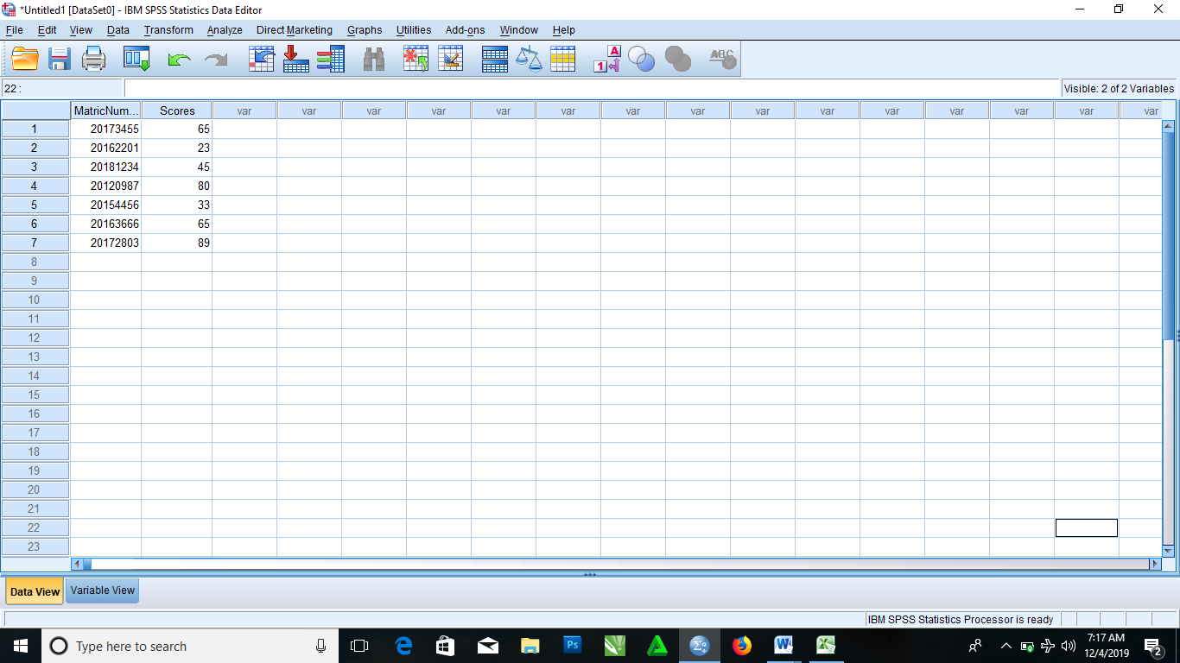

**ENTER DATA 2 INTO MICROSOFT-EXCEL AND IMPORT SAME DATA INTO SPSS AND GIVE ALL THE NECESSARY DETAILS FOR IMPORTING THE DATA INTO SPSS.**



* + From the menus choose

File > Open > Data……

* + Then select Excel(*.xls) as the file type you want to view
  + Then open demo.xls

The opening Excel data source dialog box is displayed, allowing you to specify whether variable names are to be included in the spreadsheet as well as the cells that you want to import

* + Make sure that Read Variable names from the first row of data is selected. This option reads column headings as variable names

**NOTE:** If you want to import only a portion of the spreadsheet, specify the range of cells to be imported in the range text box

* + Click OK to read the Excel File

Then the data now appear in the Data Editor, with the column headings used as variable names.

NOTE: Since variable names can’t contain spaces, the spaces from the original column headings have been removed. The original column heading is retained as a variable label.

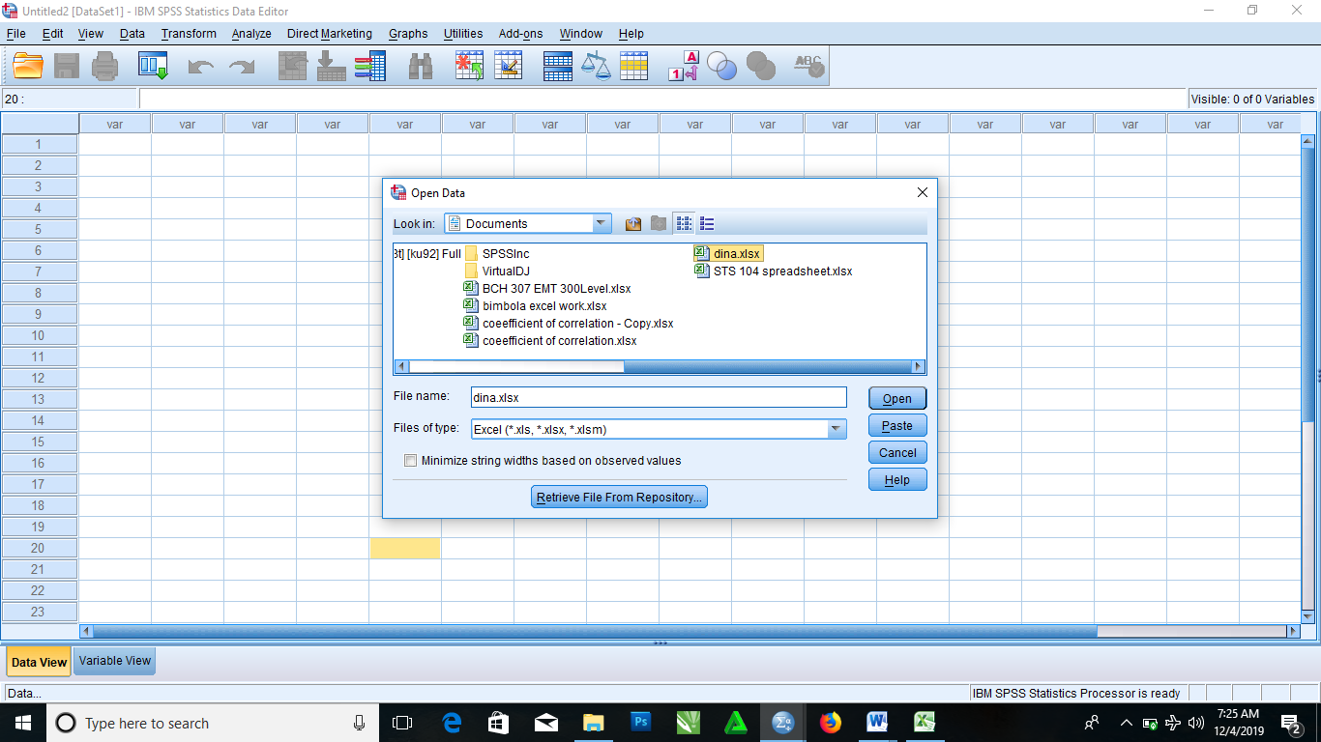

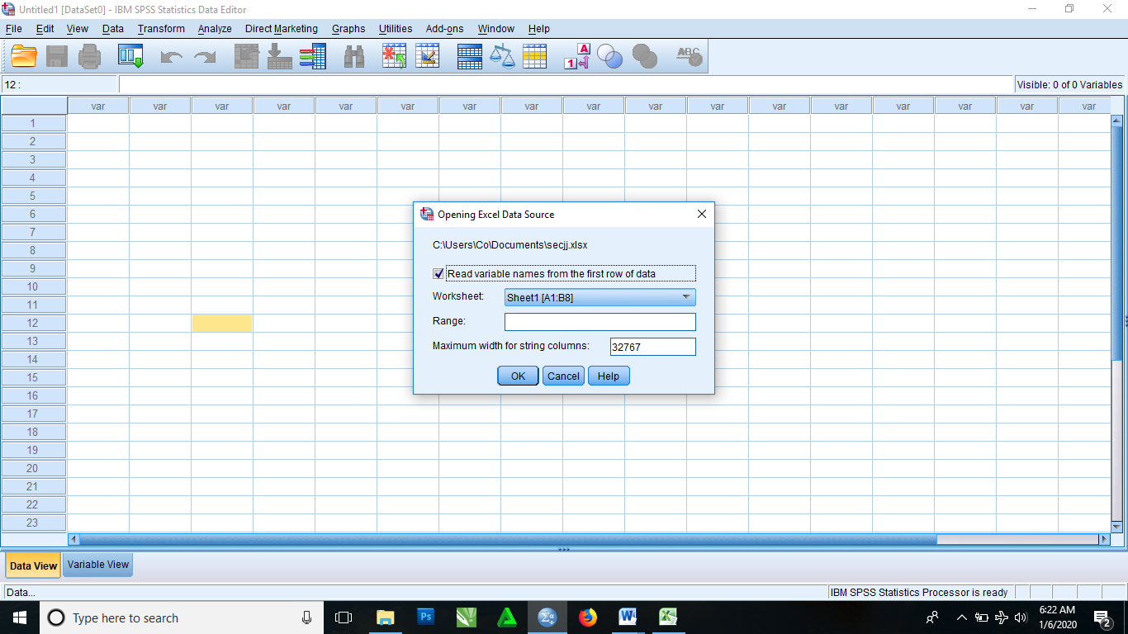

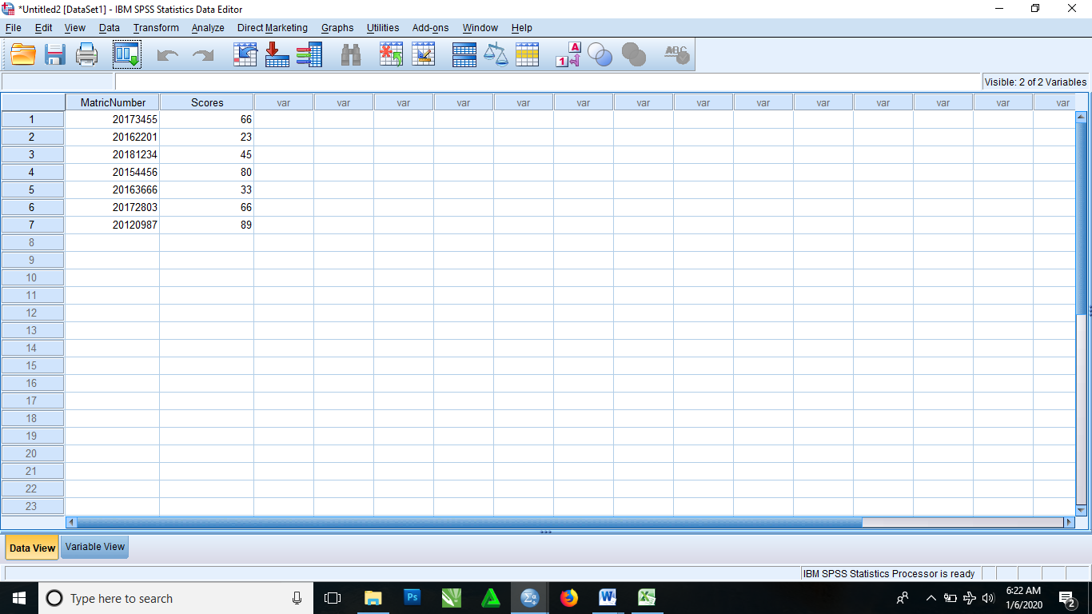

## PRACTICAL NINE: EXPLORE THE DESCRIPTIVE STATISTICS OF SPSS

These are the following steps to follow in order to get the descriptive statistics of a data.

* Input your data or Import data from other source
* From the menu select Analyze, then proceed to clicking descriptive statistics
* Select frequencies, then it brings you to a dialog box. Then you click and drag variables in question from the left box to Variable(s).

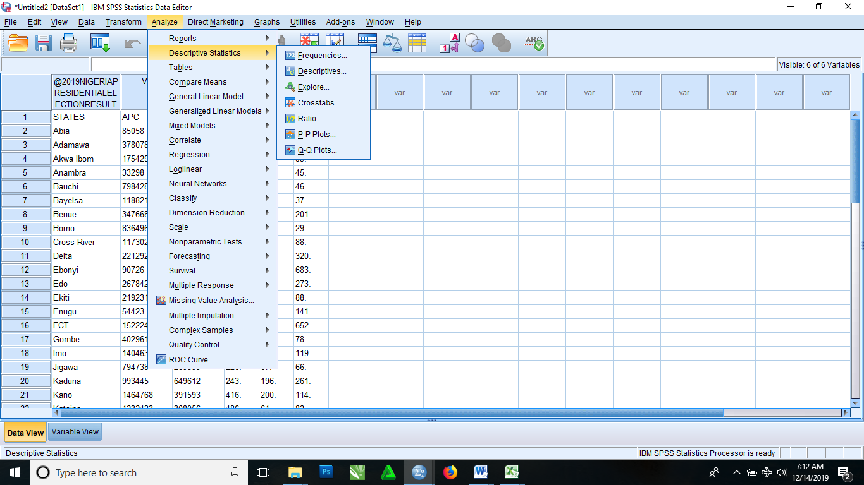

* Then click on the statistics tab, it then brings you to a dialog where you have to select every options aside from Percentile(s). Then you click on continue, it then brings you back to the previous frequencies dialog box

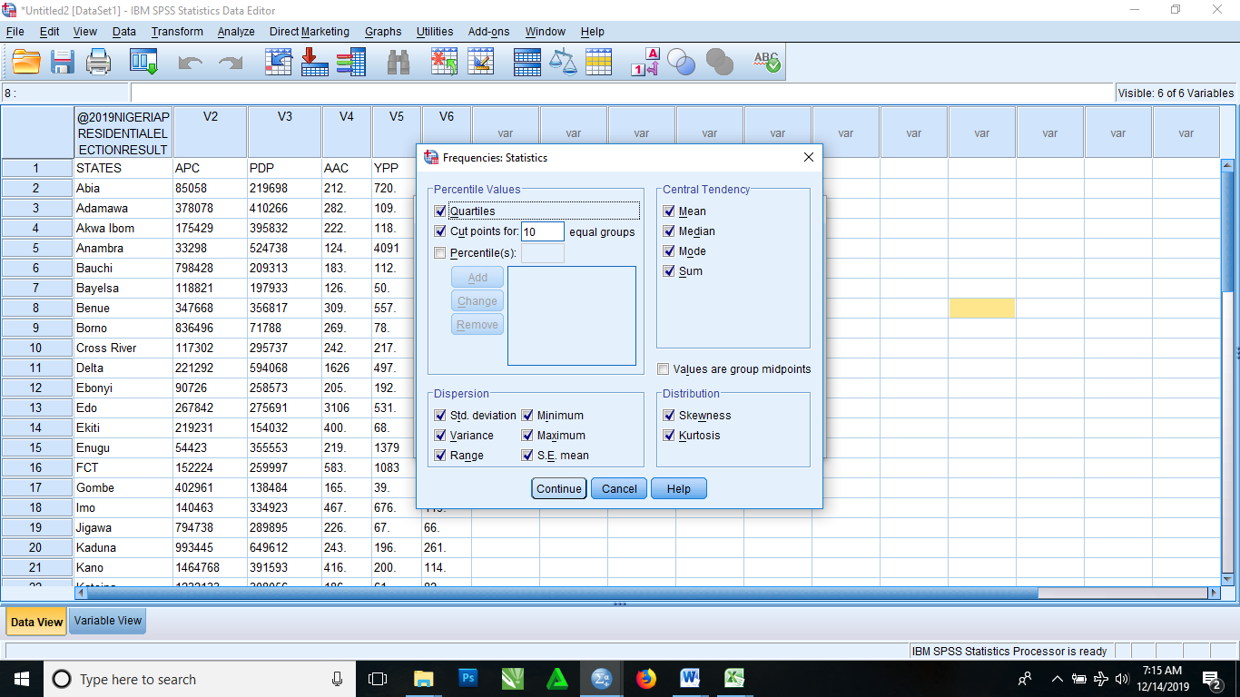

* Click OK. It then brings out a result in this format below

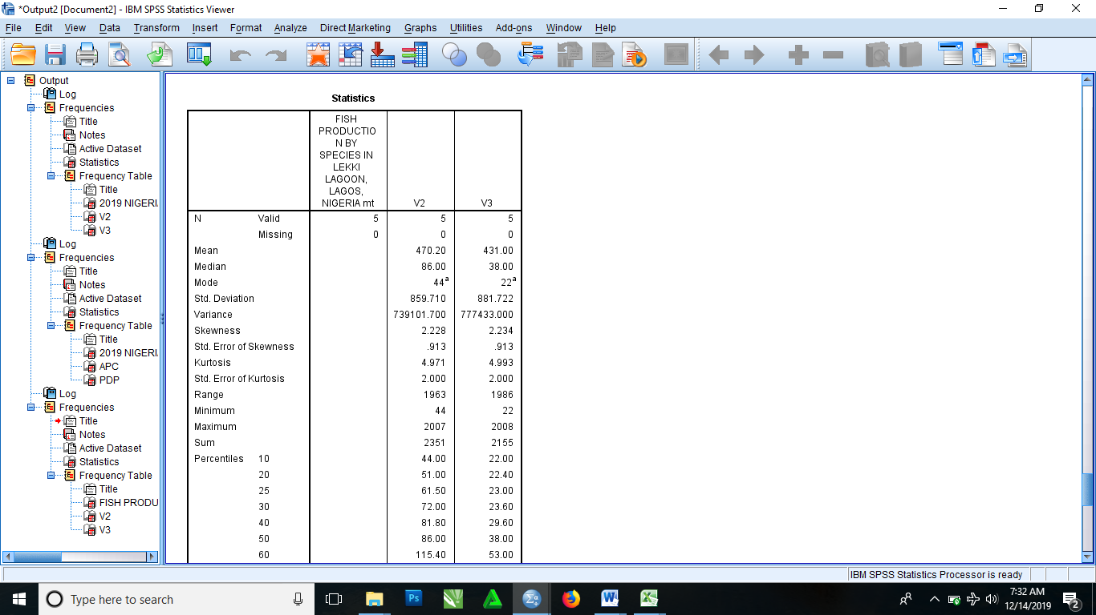

**Now to get the descriptive**

* From the menu bar again you click on Analyze, then select descriptive statistics and it takes you to another field of options and click on descriptive.

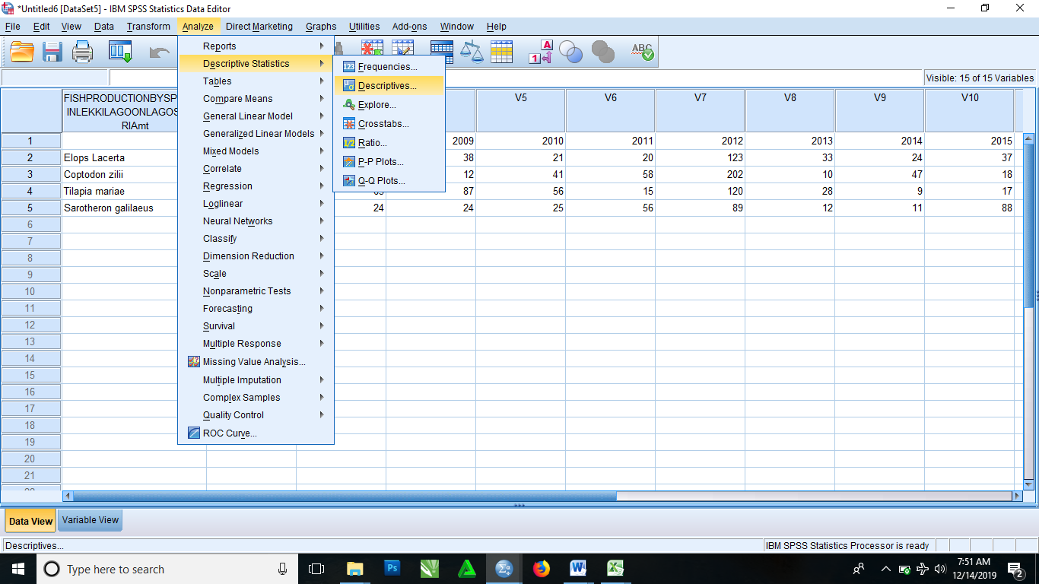

* It then brings you a dialog box where you click and drag the variables in question from the left box to the right empty box.
* Click options to select the parameters, then click continue. It then brings you back to the descriptive dialog box
* Click OK.

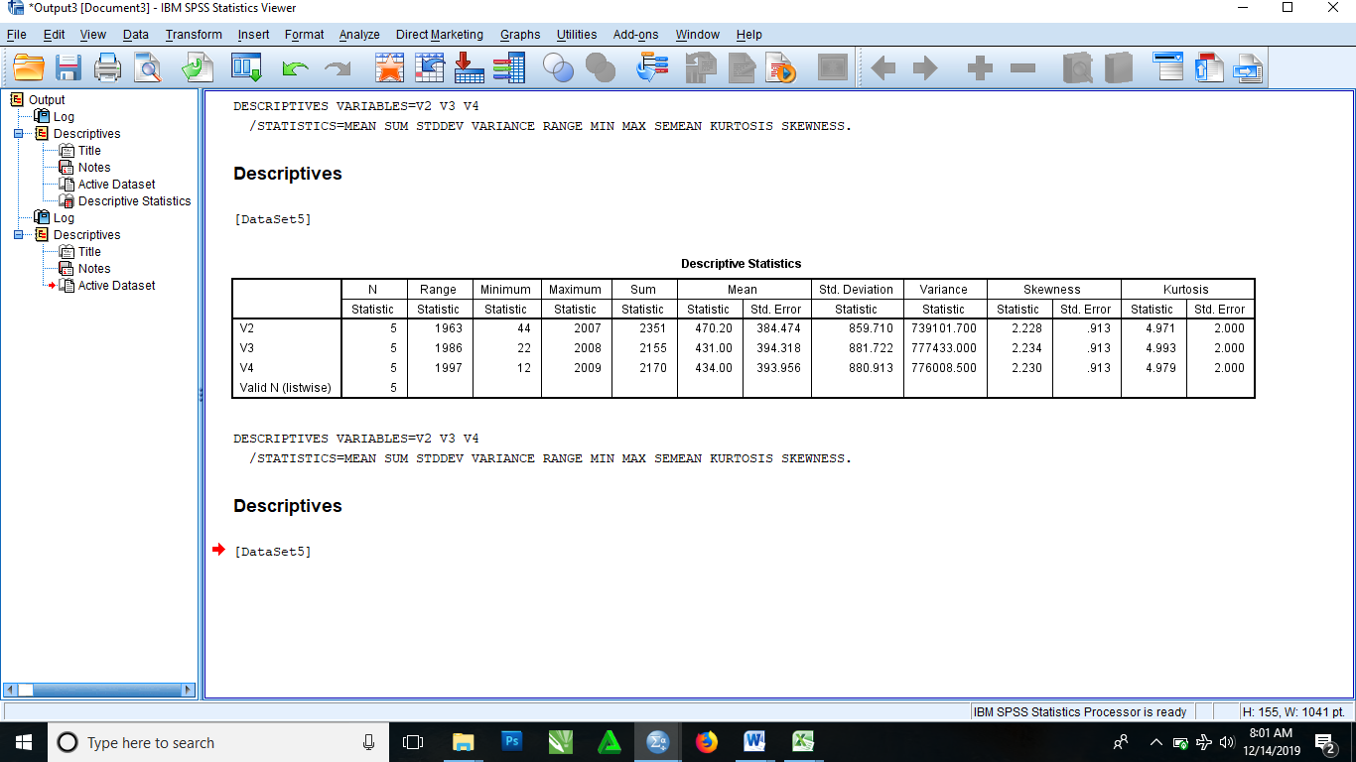

**Now to get the Crosstabulations**

* From the menu bar select analyze, then select descriptive statistics and it bring an option of choices, you then select Crosstab

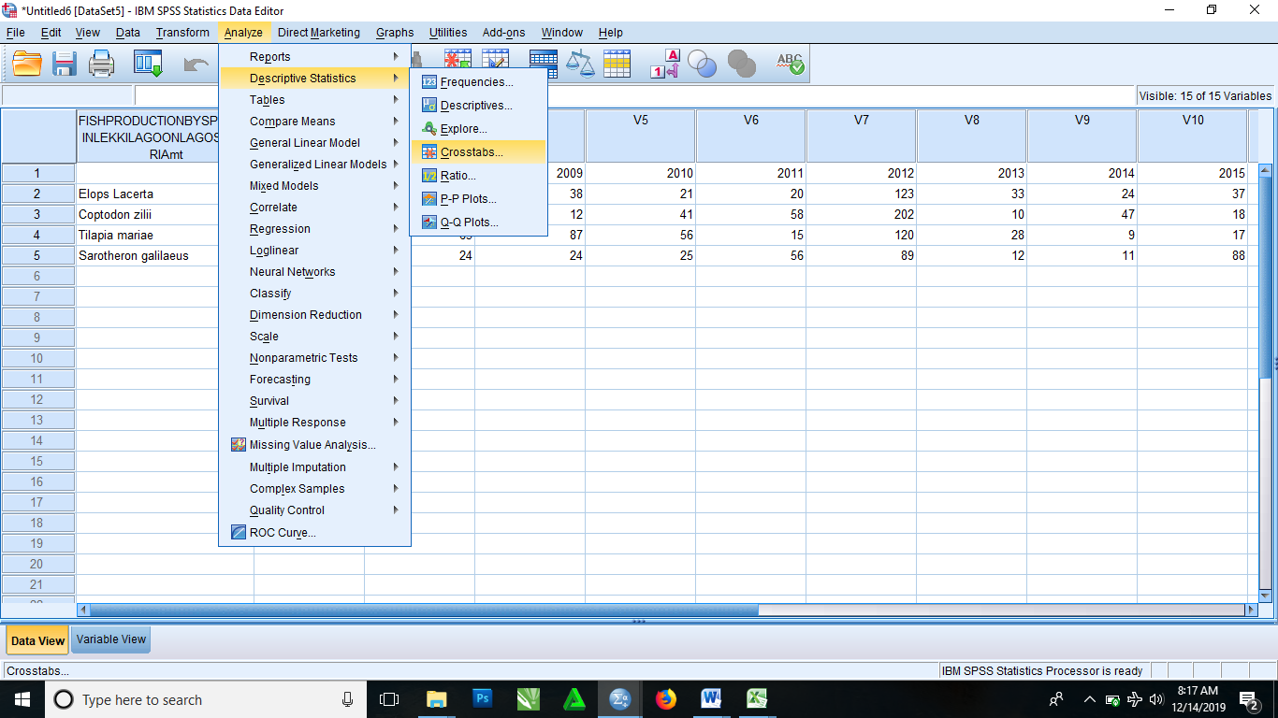

* It then brings you to Crosstab dialog box where you click and drag the variables in question from left box to each of the Row(s) box and Column(s) box on the right

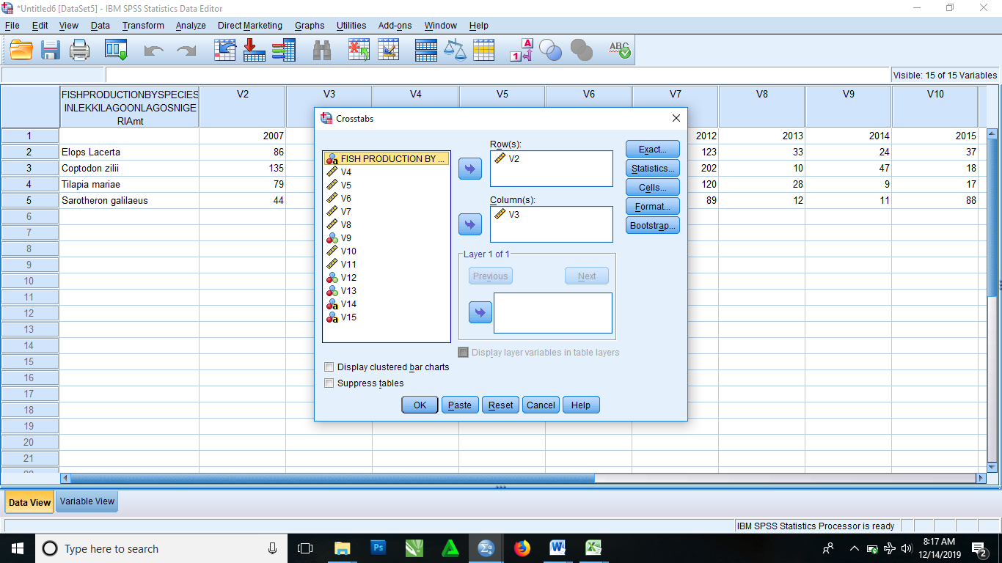

* Click OK

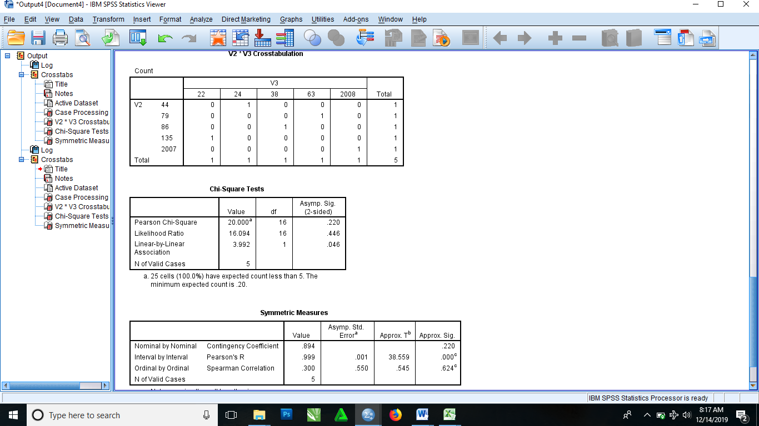

To get the Ratio Statistics

* From the menu bar select analyze, then select descriptive statistics and it brings an additional option where you then select Ratio

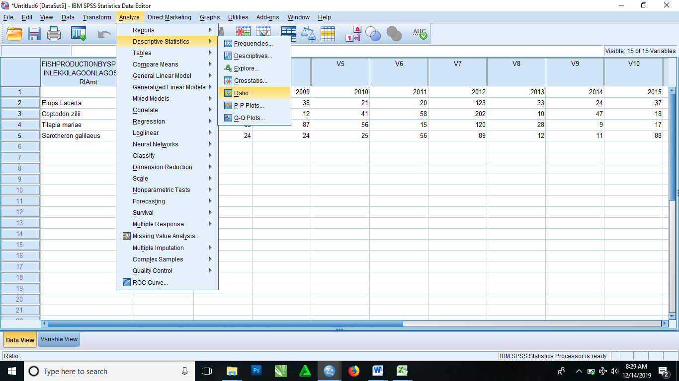

* It then brings Ratio statistics dialog box. Then you click and drag the variables in question from the left box to the right box with consist of the Numerator, Denominator and Group Variables

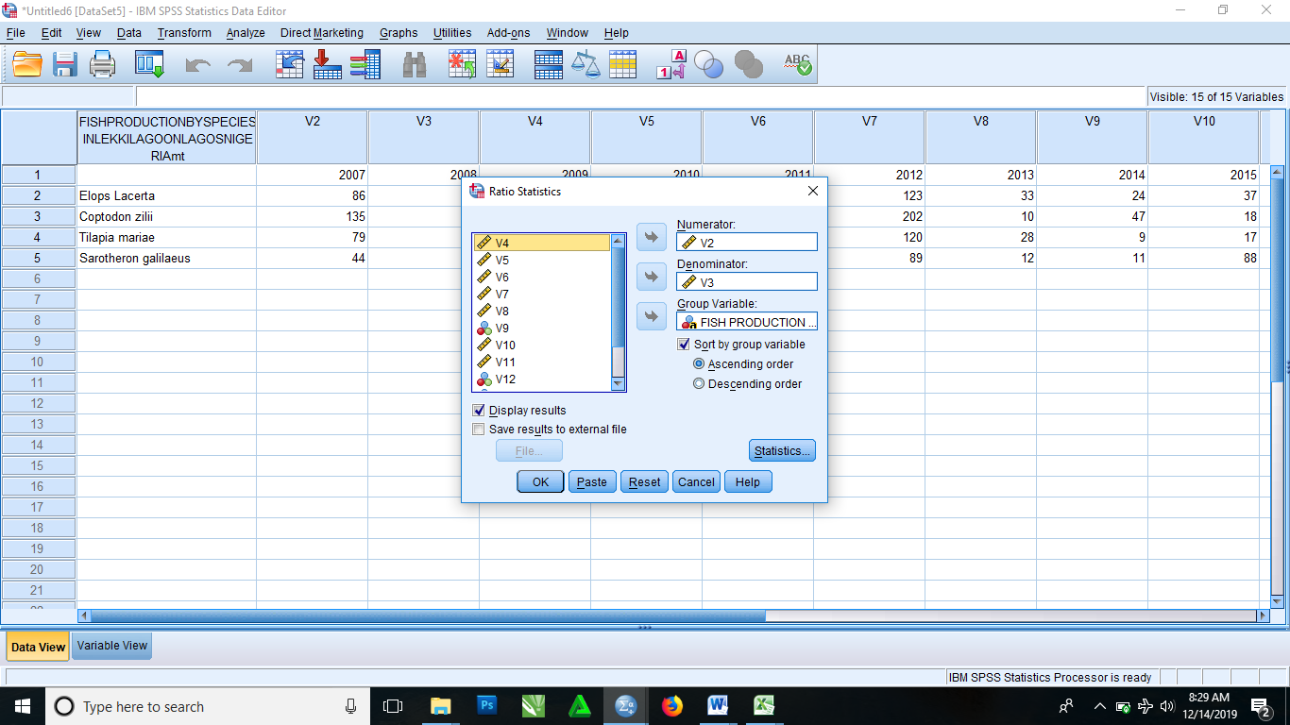

* Click OK.

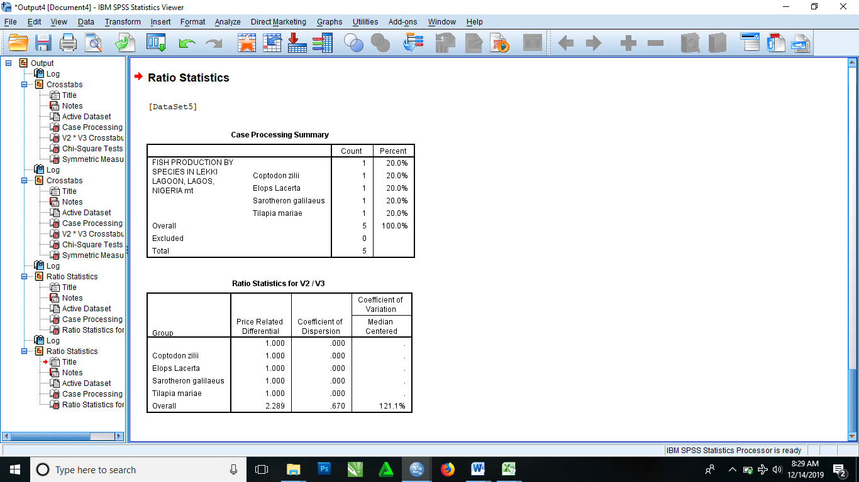

**PRACTICAL TEN: CORRELATION AND REGRESSION ON SPSS.**

1. Generate a multivariate problem and corresponding data.
2. Give a step by step procedure to obtain the pair-wise covariance and correlation of the variables with SPSS.
3. Run the analysis in (b) above.
4. Give a step by step procedure for (i) simple and (ii) multiple regression analysis with SPSS.
5. Run the analysis in (d) above and write the regression models from the outputs.

**Problem 2 on Pairwise Covariance and Correlation**

Two judges in a beauty competition rank the 12 entries as follows:

|  |  |  |  |  |  |  |  |  |  |  |  |  |
| --- | --- | --- | --- | --- | --- | --- | --- | --- | --- | --- | --- | --- |
| X | 1 | 2 | 3 | 4 | 5 | 6 | 7 | 8 | 9 | 10 | 11 | 12 |
| Y | 12 | 9 | 6 | 10 | 3 | 5 | 4 | 7 | 8 | 2 | 11 | 1 |

**DATA OUTPUT ON SPSS.**

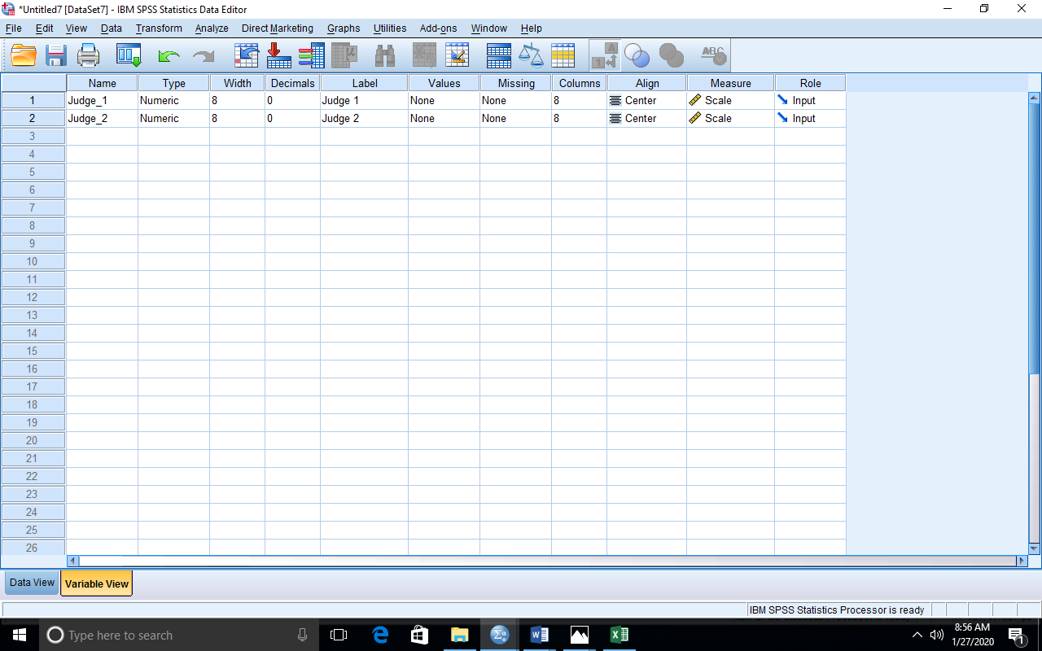

**DATA STRUCTURE ON DATA VIEW.**

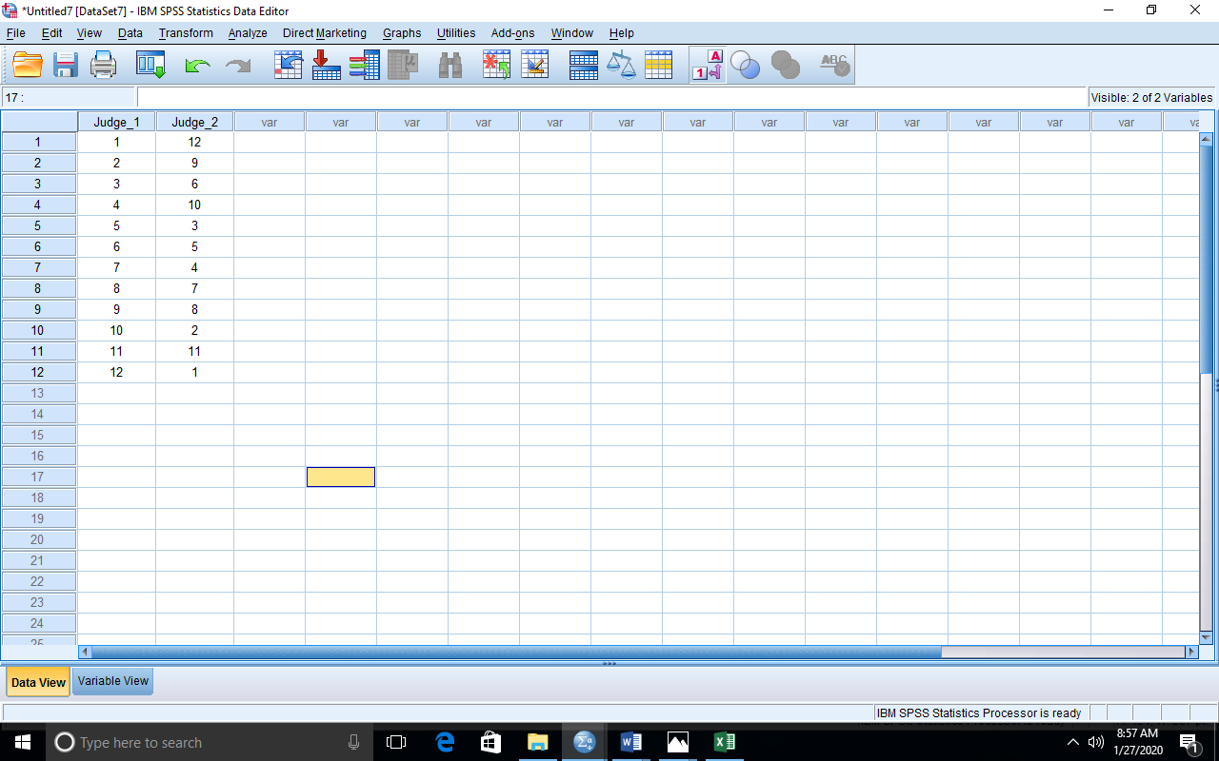

**PROCEDURES**

* Input the data into the SPSS and do the necessary editing in the variable view

From the menus, click

* Analyze > Correlate > Bivariate
* It then brings you to a Bivariate Correlations dialog box where you click and drag variables from the left box to the variables box and you drop
* Click Option
* It then brings you to a dialog box. Then you select Cross-product deviations and covariances in the statistics box and select Exclude cases pairwise in the missing values box.
* Click Continue
* Click OK.

**DATA OUTPUT ON SPSS.**

|  |  |  |  |
| --- | --- | --- | --- |
| **Correlations** | | | |
|  | | Judge 1 | Judge 2 |
| Judge 1 | Pearson Correlation | 1 | -.455 |
| Sig. (2-tailed) |  | .138 |
| Sum of Squares and Cross-products | 143.000 | -65.000 |
| Covariance | 13.000 | -5.909 |
| N | 12 | 12 |
| Judge 2 | Pearson Correlation | -.455 | 1 |
| Sig. (2-tailed) | .138 |  |
| Sum of Squares and Cross-products | -65.000 | 143.000 |
| Covariance | -5.909 | 13.000 |
| N | 12 | 12 |

**Simple regression and multiple regression**

**Problem 3 on Simple regression**

The following data give the experience of the machine operators and their performance ratings as given by the number of good parts turned out per 100 pieces.

|  |  |  |  |  |  |  |  |  |
| --- | --- | --- | --- | --- | --- | --- | --- | --- |
| Operators | 1 | 2 | 3 | 4 | 5 | 6 | 7 | 8 |
| Experience  (years) | 16 | 12 | 18 | 4 | 3 | 10 | 5 | 12 |
| Performance Ratings | 87 | 88 | 89 | 68 | 78 | 80 | 75 | 83 |

**DATA STRUCTURE ON SPSS.**

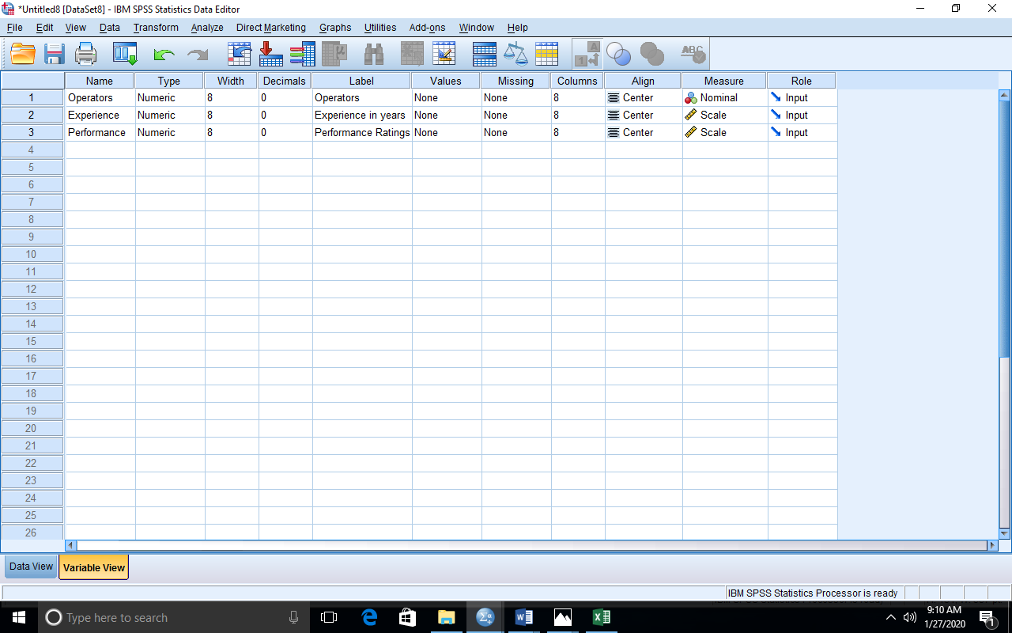

**DATA STRUCTURE ON DATA VIEW.**

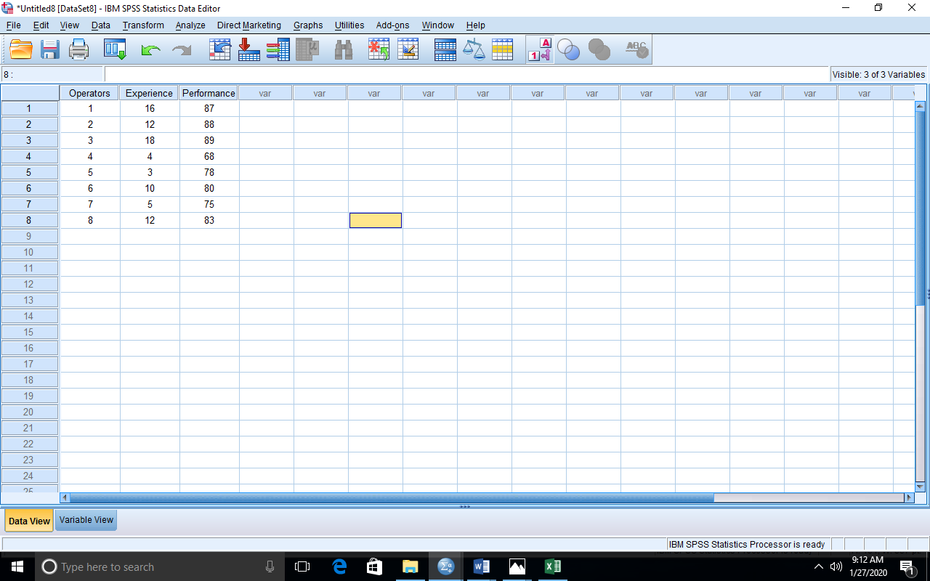

**PROCEDURES**

* From the menus, select

Analyze > Regression > Linear

* It then brings you to a dialog box. From the list of variables in the left box, you click and drag the variable Experience in years and drop it in the Independent(s) box and click and drag Performance and drop it in the Dependent box
* Click OK

**DATA OUTPUT ON SPSS**

|  |  |  |  |  |  |  |
| --- | --- | --- | --- | --- | --- | --- |
| **Coefficientsa** | | | | | | |
| Model | | Unstandardized Coefficients | | Standardized Coefficients | t | Sig. |
| B | Std. Error | Beta |
| 1 | (Constant) | 69.670 | 2.928 |  | 23.792 | .000 |
| Experience in years | 1.133 | .260 | .872 | 4.365 | .005 |
| a. Dependent Variable: Performance Ratings | | | | | | |

**REGRESSION EQUATION**

Independent variable X = Experience in years.

Dependent variable Y = Performance Ratings.

Y = 69.67 + 1.133X

**Problem 4 on multiple regression**

The following data give the score of three different courses in the college of physical science.

|  |  |  |  |  |  |  |  |  |
| --- | --- | --- | --- | --- | --- | --- | --- | --- |
| MTS223 | 67 | 78 | 89 | 67 | 77 | 78 | 89 | 48 |
| MTS241 | 87 | 88 | 89 | 23 | 54 | 65 | 76 | 98 |
| STS281 | 56 | 64 | 72 | 89 | 6 | 74 | 76 | 90 |

**DATA STRUCTURE ON DATA VIEW**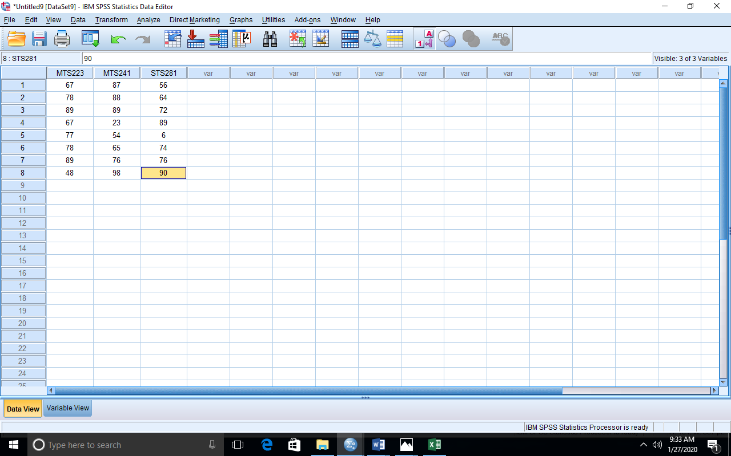

**PROCEDURES**

To get the multiple regression analyses, you follow the following procedures

* From the menus, select

Analyze > Regression > Linear

* It then brings you to a dialog box. From the list of variables in the left box, you click and drag the variables MTS241 and STS281 drop it in the Independent(s) box and click and drag MTS223 and drop it in the Dependent box
* Click OK.

**DATA OUTPUT ON SPSS.**

|  |  |  |  |  |  |  |
| --- | --- | --- | --- | --- | --- | --- |
| **Coefficientsa** | | | | | | |
| Model | | Unstandardized Coefficients | | Standardized Coefficients | t | Sig. |
| B | Std. Error | Beta |
| 1 | (Constant) | 83.700 | 21.961 |  | 3.811 | .012 |
| Mathematical method 1 | -.019 | .238 | -.035 | -.081 | .938 |
| Probability 2 | -.124 | .219 | -.247 | -.568 | .595 |
| a. Dependent Variable: Real analysis | | | | | | |

**REGRESSION EQUATION.**

Independent variables: STS281 & MTS 241.

Dependent variable: MTS223.

Y = 83.700 -0.019X1-0.124X2

**PRACTICAL 11: HYPOTHESIS TESTING WITH SPSS.**

1. Generate a one-sample problem and corresponding data.
2. Set the hypothesis with the hypothesized mean for the problem.
3. Give a step by step procedure for running the analysis with SPSS.
4. Give the SPSS data structure for the analysis and run the analysis.
5. Give the decision rule and conclusion based on the output of your analysis.
6. Generate a two-sample problem and corresponding data.
7. Set the hypothesis for the problem.
8. Give a step by step procedure for running the analysis with SPSS.
9. Give the SPSS data structure for the analysis and run the analysis.
10. Give the decision rule and conclusion based on the output of your analysis.

**One sample t test**

Prices of shares of a company on the different days in a month were found to be

|  |  |  |  |  |  |  |  |  |  |  |
| --- | --- | --- | --- | --- | --- | --- | --- | --- | --- | --- |
| Prices of shares | 66 | 65 | 69 | 70 | 69 | 71 | 70 | 63 | 64 | 68 |

A forex analyst decided to test whether the mean price of the shares in the month is 65.

**DATA STRUCTURE ON SPSS**

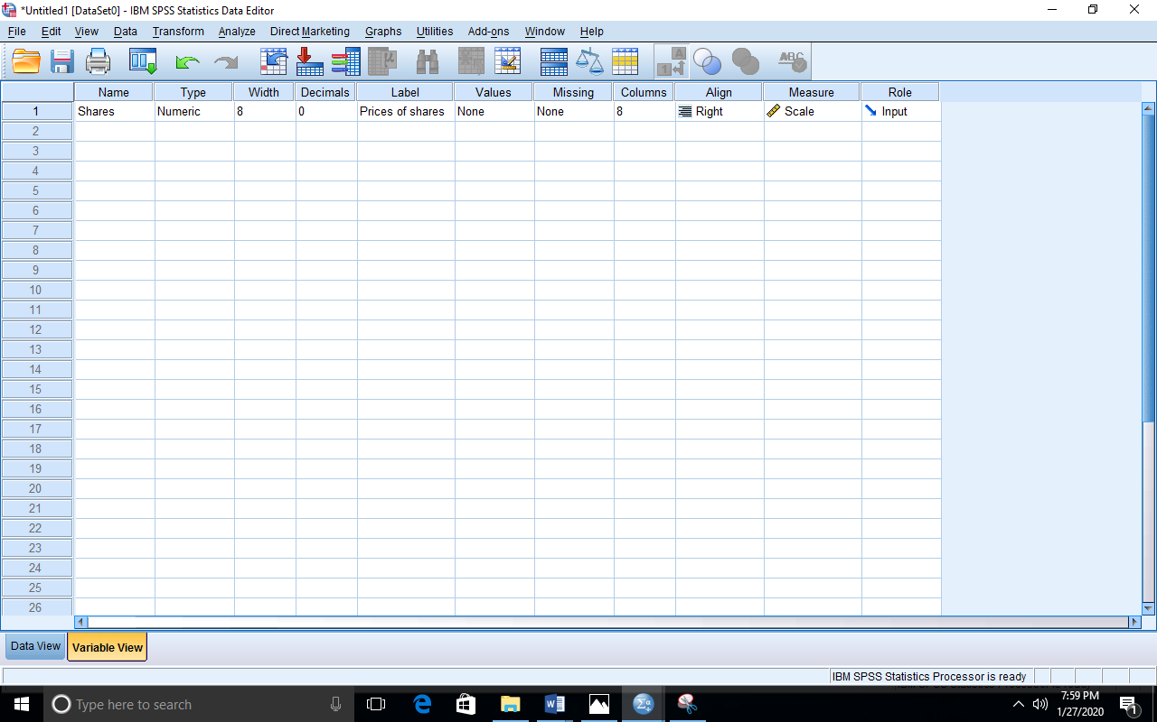

**DATA STRUCTURE ON DATA VIEW**

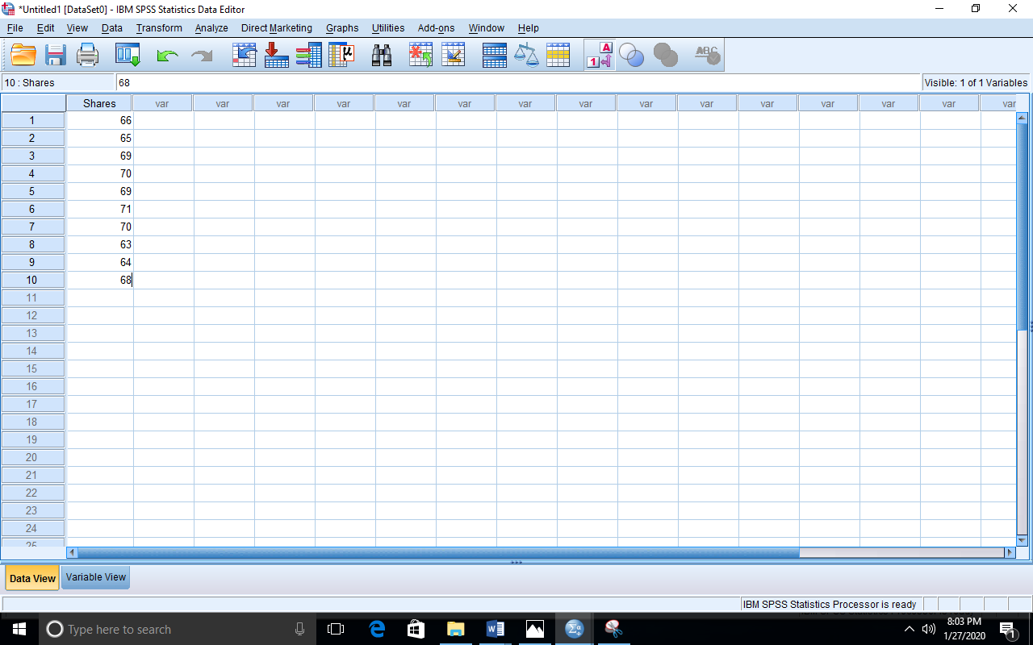

**PROCEDURES.**

* Click on SPSS to generate a new Data sets.
* Click on Analyze.
* Select Compare Means and Click on One Sample t-test.
* Click and Drag your test variable.
* Click to Select your test value.
* Click our to generate your output on SPSS output viewer.

**DATA OUTPUT ON SPSS.**

|  |  |  |  |  |  |  |
| --- | --- | --- | --- | --- | --- | --- |
| **One-Sample Test** | | | | | | |
|  | Test Value = 65 | | | | | |
| t | df | Sig. (2-tailed) | Mean Difference | 95% Confidence Interval of the Difference | |
| Lower | Upper |
| Prices of shares | 2.825 | 9 | .020 | 2.500 | .50 | 4.50 |

**DECISION.**

Since our t calculated (2.825) greater than tabulated (2.262) will reject our null hypothesis.

**Problem 1 on Paired sample t test**

A medical statistician decided to study a sample of 9 individuals will a particular drug to see if had any effect on their weight using a 1% level of significance.

|  |  |  |  |  |  |  |  |  |  |
| --- | --- | --- | --- | --- | --- | --- | --- | --- | --- |
| Weight before treatment | 47 | 43 | 41 | 44 | 60 | 66 | 76 | 68 | 78 |
| Weight after treatment | 53 | 54 | 65 | 67 | 65 | 78 | 90 | 46 | 76 |

**Statistical hypothesis**

Null Hypothesis: H0 : µA = µB i.e there is no significant difference in the weight before and after treatment.

Alternative Hypothesis: H1 : µA ≠ µB i.e there is a significant difference in the weight before and after treatment.

**DATA STRUCTURE ON DATA VIEW.**

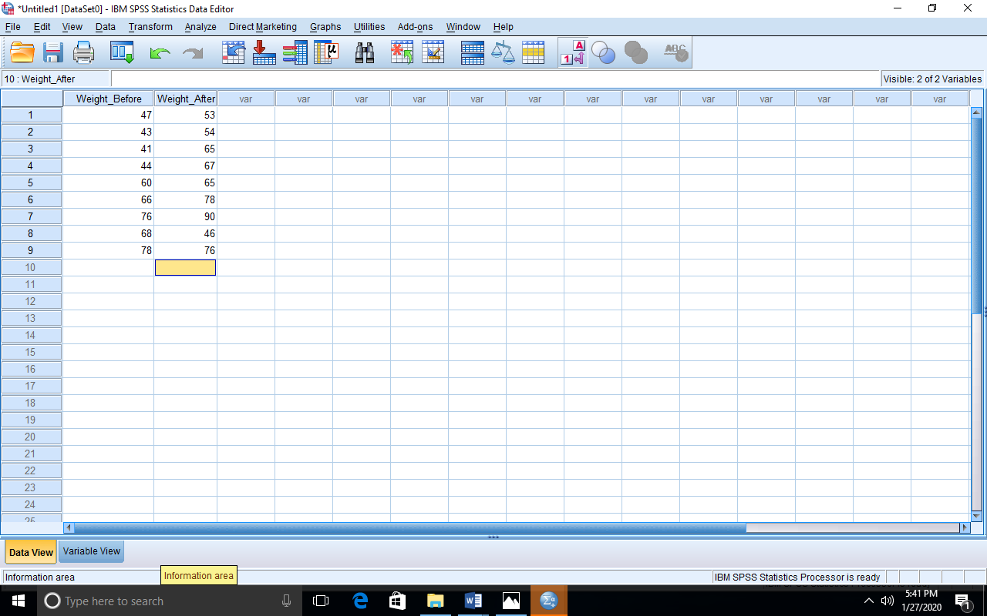

**PROCEDURES.**

* Click on SPSS to generate a new Data sets.
* Click on Analyze.
* Select Compare Means and Click on Paired sample t test.
* Click and Drag your test variable 1 & 2.
* Click ok to generate your output on SPSS output viewer.

**DATA OUTPUT ON SPSS.**

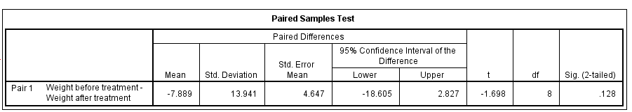

**Decision Rule**

Since our p (0.128) value is less than α will reject the null hypothesis.

**PRACTICAL TWELVE: ONE WAY AND TWO WAY ANOVA ON SPSS.**

1. Generate a one-way ANOVA problem and corresponding data.
2. Set the hypothesis for the problem.
3. Give a step by step procedure for running the analysis with SPSS .
4. Give the decision rule and conclusion based on the outcome of your analysis.
5. Give the decision rule and conclusion based on the outcome of your analysis.

**QUESTION:** Run the study of the effects of tea on weight (kg) loss of patients with respect to Green Tea, Black Tea and No Tea.

* After inputting your data and noting every condition.

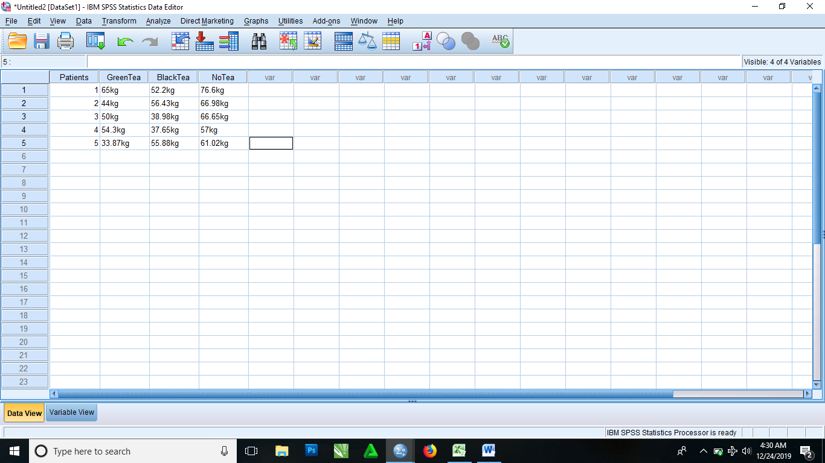

* From the menu

Select Analyze > Compare means > One way ANOVA

* It then brings you to a dialog box, where you select Patient and drag to the Factor box and also select and drag other variables to the Dependent List box
* Click OK.

|  |  |  |  |  |  |  |
| --- | --- | --- | --- | --- | --- | --- |
| **ANOVA** | | | | | | |
|  | | Sum of Squares | df | Mean Square | F | Sig. |
| GreenTea | Between Groups | 538.065 | 4 | 134.516 | . | . |
| Within Groups | .000 | 0 | . |  |  |
| Total | 538.065 | 4 |  |  |  |
| NoTea | Between Groups | 218.931 | 4 | 54.733 | . | . |
| Within Groups | .000 | 0 | . |  |  |
| Total | 218.931 | 4 |  |  |  |
| BlackTea | Between Groups | 339.022 | 4 | 84.756 | . | . |
| Within Groups | .000 | 0 | . |  |  |
| Total | 339.022 | 4 |  |  |  |

1. Generate a two samples problem and corresponding data.
2. Set the hypothesis for the problem.
3. Give a step by step procedure for running the analysis with SPSS.
4. Give the SPSS data structure for the analysis and run the analysis.
5. Give the decision rule and conclusion based on the outcome of your analysis.

**SOLUTION**

* After inputting your data into the SPSS

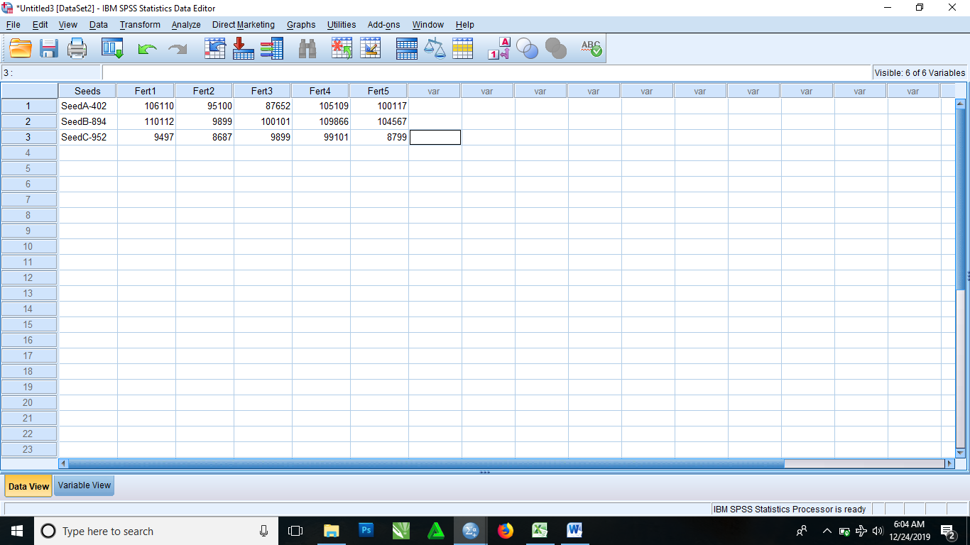

* From the menus
* Select Analyze > General Linear Model > Multivariate
* It then brings you to a dialog box where you click and drag Seed to the fixed factor(s) box and then click and drag other variables to the Dependent Variables box
* Click OK.

|  |  |  |  |  |  |  |  |
| --- | --- | --- | --- | --- | --- | --- | --- |
| **Tests of Between-Subjects Effects** | | | | | | | |
| Source | Dependent Variable | Type III Sum of Squares | df | Mean Square | F | Sig. | Partial Eta Squared |
| Corrected Model | Fert1 | 6491155332.667a | 2 | 3245577666.333 | . | . | 1.000 |
| Fert2 | 4909295304.667a | 2 | 2454647652.333 | . | . | 1.000 |
| Fert3 | 4778969138.000a | 2 | 2389484569.000 | . | . | 1.000 |
| Intercept | Fert1 | 16983022320.333 | 1 | 16983022320.333 | . | . | 1.000 |
| Fert2 | 4308168865.333 | 1 | 4308168865.333 | . | . | 1.000 |
| Fert3 | 13022104368.000 | 1 | 13022104368.000 | . | . | 1.000 |
| Seeds | Fert1 | 6491155332.667 | 2 | 3245577666.333 | . | . | 1.000 |
| Fert2 | 4909295304.667 | 2 | 2454647652.333 | . | . | 1.000 |
| Fert3 | 4778969138.000 | 2 | 2389484569.000 | . | . | 1.000 |
| Error | Fert1 | .000 | 0 | . |  |  |  |
| Fert2 | .000 | 0 | . |  |  |  |
| Fert3 | .000 | 0 | . |  |  |  |
| Total | Fert1 | 23474177653.000 | 3 |  |  |  |  |
| Fert2 | 9217464170.000 | 3 |  |  |  |  |
| Fert3 | 17801073506.000 | 3 |  |  |  |  |
| Corrected Total | Fert1 | 6491155332.667 | 2 |  |  |  |  |
| Fert2 | 4909295304.667 | 2 |  |  |  |  |
| Fert3 | 4778969138.000 | 2 |  |  |  |  |
| 1. R Squared = 1.000 (Adjusted R Squared = .)   **PRACTICAL THIRTEEN ON SPSS: THREE AND FOUR WAY ANOVA ON SPSS.** | | | | | | | |

1. Generate a LS problem and corresponding data.
2. Set the hypothesis for the problem.
3. Give a step and step procedure for running the analysis with SPSS.
4. Give the SPSS data structure for the analysis and run the analysis.
5. Give the decision rule and conclusion based on the outcome of your analysis
6. Generate a GLS problem and corresponding data.
7. Set the hypothesis analysis for the problem.
8. Give a step by step procedure for running the analysis with SPSS
9. Give the SPSS data structure for the analysis and run the analysis
10. Give the decision rule and conclusion based on the outcome of your analysis.

SOLUTION

A research to examine a new class of drug that has the potential to lower cholesterol levels and thus helps against heart attack on both male and female.

**Null Hypothesis** Ho: **The new class of drugs might affect male and female differently**.

**Alternative Hypothesis** H1: **The new class of drugs might not affect male and female differently**.

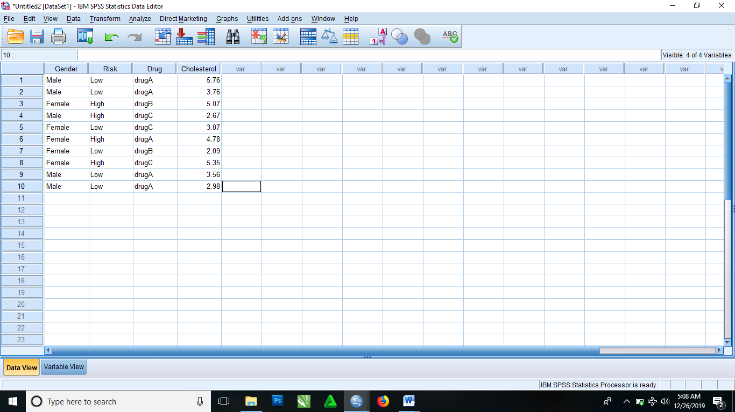

After inputting your data into SPSS and doing all necessary editing in the variable view. Then,

**PROCEDURES**

* From the menus, select

Analyze > General Linear Model > Univariate

* It then brings you to Univariate dialog box where you select variables from list of variables in the left box. Then click on Cholesterol, drag and drop in the Dependent variable box. Click on Gender, Risk and Drug, drag and drop them in the Fixed Factor(s) box.
* Click on Options
* It then brings you to a dialog box. In this dialog box there is list of variables in the Factor(s) and Factor interactions box, then click and drag Gender*Risk*Drug

Then proceed to the Display dialog box then select Descriptive statistics and Homogeneity tests.

* Click Continue
* Click OK

|  |  |  |  |  |  |
| --- | --- | --- | --- | --- | --- |
| **Tests of Between-Subjects Effects** | | | | | |
| Dependent Variable: Cholesterol | | | | | |
| Source | Type III Sum of Squares | df | Mean Square | F | Sig. |
| Corrected Model | 9.776a | 6 | 1.629 | 1.114 | .505 |
| Intercept | 99.105 | 1 | 99.105 | 67.752 | .004 |
| Gender | 3.591 | 1 | 3.591 | 2.455 | .215 |
| Risk | 6.917 | 1 | 6.917 | 4.729 | .118 |
| Drug | .520 | 2 | .260 | .178 | .845 |
| Gender * Risk | .000 | 0 | . | . | . |
| Gender * Drug | .000 | 0 | . | . | . |
| Risk * Drug | .122 | 1 | .122 | .084 | .791 |
| Gender * Risk * Drug | .000 | 0 | . | . | . |
| Error | 4.388 | 3 | 1.463 |  |  |
| Total | 166.967 | 10 |  |  |  |
| Corrected Total | 14.164 | 9 |  |  |  |
| a. R Squared = .690 (Adjusted R Squared = .071) | | | | | |

|  |  |  |  |  |  |  |
| --- | --- | --- | --- | --- | --- | --- |
| **Gender * Risk * Drug** | | | | | | |
| Dependent Variable: Cholesterol | | | | | | |
| Gender | Risk | Drug | Mean | Std. Error | 95% Confidence Interval | |
| Lower Bound | Upper Bound |
| Female | High | drugA | 4.780 | 1.209 | .931 | 8.629 |
| drugB | 5.070 | 1.209 | 1.221 | 8.919 |
| drugC | 5.350 | 1.209 | 1.501 | 9.199 |
| Low | drugA | .a | . | . | . |
| drugB | 2.090 | 1.209 | -1.759 | 5.939 |
| drugC | 3.070 | 1.209 | -.779 | 6.919 |
| Male | High | drugA | .a | . | . | . |
| drugB | .a | . | . | . |
| drugC | 2.670 | 1.209 | -1.179 | 6.519 |
| Low | drugA | 4.015 | .605 | 2.090 | 5.940 |
| drugB | .a | . | . | . |
| drugC | .a | . | . | . |
| a. This level combination of factors is not observed, thus the corresponding population marginal mean is not estimable. | | | | | | |